THEORETICAL COMPETITION
January 15, 2013

Please read this first:

- The time available for the theoretical competition is 4 hours. There are three questions.
- Use only the pen provided.
- You can use your own calculator for numerical calculations. If you don’t have one, please ask for it from Olympiad organizers.
- You are provided with Writing sheet and additional paper. You can use the additional paper for drafts of your solutions but these papers will not be checked. Your final solutions which will be evaluated should be on the Writing sheets. Please use as little text as possible. You should mostly use equations, numbers, figures and plots.
- Use only the front side of Writing sheets. Write only inside the boxed area.
- Begin each question on a separate sheet of paper.
- Fill the boxes at the top of each sheet of paper with your country (Country), your student code (Student Code), the question number (Question Number), the progressive number of each sheet (Page Number), and the total number of Writing sheets used (Total Number of Pages). If you use some blank Writing sheets for notes that you do not wish to be evaluated, put a large X across the entire sheet and do not include it in your numbering.
- At the end of the exam, arrange all sheets for each problem in the following order:
- Used Writing sheets in order;
- The sheets you do not wish to be evaluated
- Unused sheets and the printed question.
Place the papers inside the envelope and leave everything on your desk. You are not allowed to take any paper out of the room.

Problem 1 (10 points)
This problem consists of three independent parts.

Problem 1.A Pulley (5,0 points)
The rope of length and mass is put on the pulley of radius . The rope begins to slide off the pulley without friction. Consider the time moment when the difference in height between the hanging ends of the rope is equal half of the rope length. For this time moment find the following:
1. acceleration of the rope;
2. the tension of the rope at the top of the pulley;
3. the point of the rope at which the tension is maximum (it is enough to find the angle between the radius to that point and the vertical).

Problem 1.B Assistant Vapor (2.0 points)
In the physical laboratory the thermometer reading was 20 ºC, and the barometer reading was 1 atm. The laboratory assistant Vapor pulled out a sturdy vessel of the closet, poured some water into it and sealed it with the lid. Then assistant Vapor slowly heated the vessel to the temperature 200 ºC. At this temperature, the pressure in the vessel turned out to be 2,88 atm. Find the temperature at which all the water evaporated. Justify your answer.

Problem 1.C Pyramid (3.0 points)
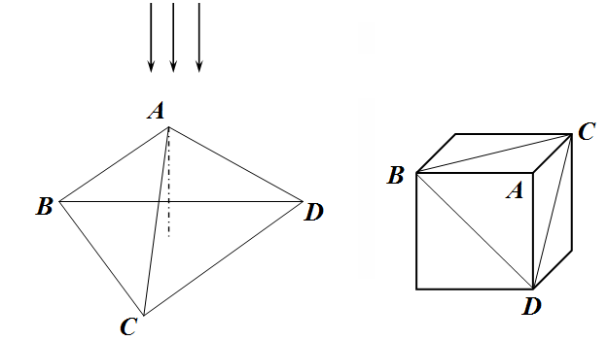
A regular triangular pyramid $\text{ABCD}$ is made of a transparent material with the refraction index $n=1,6$. All angles at the top of the pyramid are right. The base of the pyramid forms a right triangle whose sides’ lengths are equal . The pyramid can be thought of as "a corner cut off from the cube." The pyramid is homogeneously illuminated such that the light falls along its height, perpendicular to the base plane.
1. Draw an area at the base of the pyramid illuminated by the light refracted in the plane ABC.
2. A screen is placed in parallel to the pyramid base at a distance of from it. Draw areas illuminated by the light refracted by the pyramid. Specify the position and sizes of these areas.

Problem 2 (10 points)
Square frame (10 points)
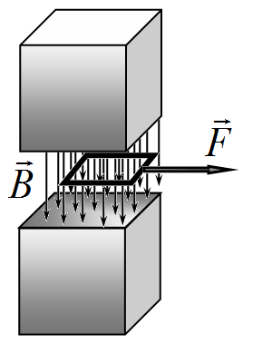
A square frame of side sm is placed in a uniform magnetic field of T generated by a permanent magnet. Completely neglect edge effects, assuming that the magnetic field between the poles of the magnet is uniform and is equal to zero outside of it. In all parts of the problem assume that at the initial time moment the frame of mass g is at rest at the edge of the poles of the magnet, see figure.
1. [0.2 points] Redraw schematically the figure on the right to identify which of the poles of the magnet is the north N and which is the south S.

Part A
Let the frame be made of a conductive material with the resistance ohm and a negligible inductance. At the time momnet the frame is subject to the constant force N, which pulles the frame out of the magnetic field.
2. [1.2 points] Find an analytical dependence of the frame velocity on time assuming that the frame remains at all times between the poles of the magnet. Express your answer in tems of and .
3. [0.8 points] Write down an exact equation to determine the time interval at which the frame moves between the poles of the magnet. Express your answer in terms of and . Estimate .
4. [1.2 points] Draw a graph of the frame velocity on time in the interval from 0 to 12s.
5. [1.2 points] Draw a graph of the frame current on time in the interval from 0 to 12s.
Part B
Let the frame be made of a superconducting material with the inductance of H, the same mass and sizes. At the time momnet s the frame is subject to a constant force which pulles the frame out of the magnetic field.
6. [1.8 points] Find the minimum force with which the frame can be pulled out of the magnet. Express your answer in terms of and calculate its numerical value.
7. [0.6 points] At the assumptions of section 6 find the minimum time interval of the maximum departure of the frame out of the magnet. Express your answer in terms of and calculate its numerical value.
8. [1.0 points] Draw a graph of the frame current on time in the interval from 0 to .
Part C
A square frame with sides is made of a conductive material with the inductance,the resistance and the mass . At the time moment the frame is given an initial velocity directed exactly as the force in the figure above. It is known that at the time moment when the frame almost leaves the magnet its velocity turns zero.
9. [2.0 points] Find an analytical expression for the frame current at the time moment when the frame velocity turns zero. Express your answer in terms of and .

Problem 3
Bohr’s model of a hydrogen atom (10 points)
Consider a hydrogen atom, which consists of a proton, whose mass can be assumed virtually infinite, and an electron of mass kg. The proton has a positive charge of Cl and the electron has a negative charge , so that the atom is totally neutral.
1. [2.0 points] It is known that most of the atoms are stable and can exist for a long time. This means that the electron being in the hydrogen atom cannot be at rest since the attraction force would inevitably make it fall onto the proton. Let the distance between the electron and the proton be equal to m/ Assuming that the laws of classical physics are applicable, find the time that the initially motionless electron needs to fall onto the proton.
Hence, to guarantee the stability of the hydrogen atom, the electron must move around the proton like the planets revolve around the Sun. Let the electron orbit be circular and assume again that the laws of classical physics can still be applied.
2. [1.0 points] Find the electron velocity as a function of the orbit radius .
3. [0.5 points] Find the angular momentum of the electron as a function of the orbit radius .
Danish physicist Niels Bohr postulated that the angular momentum of the electron is an integer of the Planck constant Дж∙с, that is , where is the main quantum number.
4. [0.5 points] Find the possible radii of the electron orbits in the hydrogen atom.
5. [0.5 points] Calculate the numerical value of the minimum radius of the electron orbit in the hydrogen atom.
6. [1.0 points] Find the possible values ​​of the total energy of the electron in the hydrogen atom.
7. [0.5 points] Calculate the numerical value of the minimum total energy of the electron in the hydrogen atom.
According to classical electrodynamics, if the electron is accelerated, it loses its energy due to electromagnetic radiation. The power of the radiation is given by
,
where is the electron acceleration, F/m is the dielectric constant, m / s is the speed of light in vacuum.
Electromagnetic radiation would lead to the fact that in the Bohr model the electron would fall onto the proton. In the following assume that the electron orbit is almost circular.
8. [1.5 points] Assuming that at the time moment the electron moves in the orbit with the radius , find the dependence of the orbit radius on time .
9. [0.5 points] Find and calculate the time that is needed for the electron to fall from the orbit with the radius onto the proton.
10. [2.0 points] How many revolutions around the proton can the electron make during its fall for the time interval ?

