Solutions of the experimental problem

Part 1.

1.1 The power of energy losses equals
$P=\text{Fv}={βv}^{n+1}$,
therefore the energy loss during a single period can be represented as
$ΔE=\left\langle P\right\rangle T=β\left\langle v^{n+1}\right\rangle T=βT\left\langle {\left(v_{0}\text{sin}ωt\right)}^{n+1}\right\rangle =β{\text{Tv}}_{0}^{n+1}\left\langle {\left(\text{sin}ωt\right)}^{n+1}\right\rangle$.
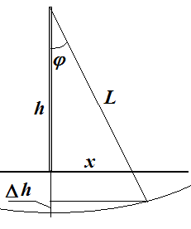
where $v_{0}$ - is the largest speed of the ball (assuming small damping). Energy of the ball is proportional to the square of the largest speed, $E_{0}=\frac{{\text{mv}}_{0}^{2}}{2}$. From here we obtain Eq. (3) of the problem set
$ΔE=−{\text{CE}}_{0}^{\frac{n+1}{2}}$. (1)
1.2 At the point of maximal deviation the total mechanical energy equals only to the potential energy, thus
$E=\text{mgL}\left(1−\text{cos}ϕ\right)$. (2)
1.3 The declination angle can be calculated using the equation
$ϕ=\text{arcsin}\frac{x}{\sqrt{x^{2}+h^{2}}}$ (3)
Initial energy and its losses can be evaluated using equations
$E_{0}=1−\text{cos}ϕ_{0}$. (4)
$ΔE=\text{cos}ϕ_{1}−\text{cos}ϕ_{0}$. (5)

Results of measurements and calculations are shown in Table 1
Table 1.
$x_{0}$, cm | $x_{1}$, cm | $x_{1}$, cm | $x_{1}$, cm | $\left\langle x_{1}\right\rangle$, сm | $$E_{0}$$ | $$ΔE$$ | $$\text{ln}E_{0}$$ | $$\text{ln}ΔE$$
25 | 20,6 | 20,7 | 20,5 | 20,6 | 0,1092 | 0,0311 | -2,21 | -3,47
24 | 20,0 | 19,5 | 20,5 | 20,0 | 0,1019 | 0,0278 | -2,28 | -3,58
23 | 19,0 | 19,0 | 19,5 | 19,2 | 0,0948 | 0,0261 | -2,36 | -3,65
22 | 18,0 | 18,5 | 18,6 | 18,4 | 0,0877 | 0,0241 | -2,43 | -3,73
21 | 17,5 | 17,6 | 17,8 | 17,6 | 0,0809 | 0,0218 | -2,52 | -3,83
20 | 17,0 | 17,1 | 17,1 | 17,1 | 0,0742 | 0,0185 | -2,60 | -3,99
19 | 16,6 | 16,5 | 16,6 | 16,6 | 0,0676 | 0,0150 | -2,69 | -4,20
18 | 15,6 | 15,4 | 15,5 | 15,5 | 0,0613 | 0,0148 | -2,79 | -4,22
17 | 15,0 | 14,9 | 14,8 | 14,9 | 0,0552 | 0,0120 | -2,90 | -4,42
16 | 14,0 | 14,2 | 14,2 | 14,1 | 0,0494 | 0,0102 | -3,01 | -4,58
15 | 13,5 | 13,3 | 13,5 | 13,4 | 0,0438 | 0,0082 | -3,13 | -4,80
14 | 12,6 | 12,4 | 12,6 | 12,5 | 0,0385 | 0,0073 | -3,26 | -4,92
13 | 11,8 | 11,5 | 11,6 | 11,6 | 0,0334 | 0,0064 | -3,40 | -5,05
12 | 10,7 | 10,7 | 10,7 | 10,7 | 0,0287 | 0,0057 | -3,55 | -5,17
11 | 10,0 | 9,8 | 9,9 | 9,9 | 0,0243 | 0,0045 | -3,72 | -5,41
10 | 9,2 | 9,3 | 9,3 | 9,3 | 0,0202 | 0,0028 | -3,90 | -5,89
9 | 8,2 | 8,0 | 8,3 | 8,2 | 0,0165 | 0,0028 | -4,11 | -5,86
8 | 7,5 | 7,4 | 7,3 | 7,4 | 0,0131 | 0,0019 | -4,34 | -6,29

Plot of the energy losses with respect to initial energy is shown in Fig. 1.
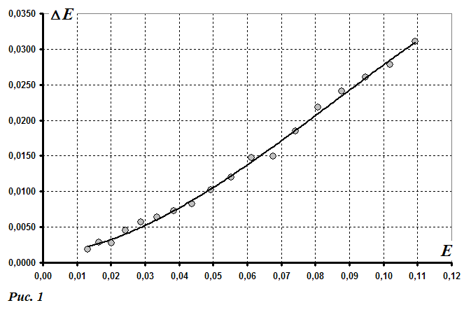
1. 4 Experimentally obtained curve looks similar to a power law. To determine the power it is most convenient to use a double logarithmic scale,
$\text{ln}\left|ΔE\right|=\text{ln}C+\frac{n+1}{2}\text{ln}E_{0}$, (6)
such that the tangent is related to the exponent. Logarithms of measured parameters are also shown in Table 1. The plot of the required dependence in the double logarithmic scale is shown in Fig. 2. Tangent of this plot is approximately equal to $\frac{n+1}{2}≈1,\text{35}$, which leads to $n≈1,7$.
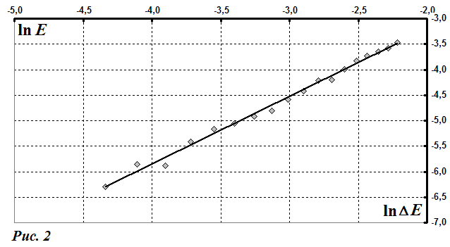
1.5 Obtained exponent is closer to 2, so Eq.(2) describes the experimental data better than eq.(1).

Part 2.

2.1 Results of the measurements are shown in Fig. 2.

Table 2.

$$k$$ | $x_{k}$, cm | $x_{k}$, cm | $x_{k}$, cm | $\left\langle x_{k}\right\rangle$, cm | $$\frac{1}{\left\langle x_{k}\right\rangle }$$ | $$\text{ln}\left\langle x_{k}\right\rangle$$
0 | 25,0 | 25,0 | 25,0 | 25,0 | 0,040 | 3,219
1 | 22,0 | 21,0 | 21,0 | 21,3 | 0,047 | 3,060
2 | 18,0 | 17,5 | 17,7 | 17,7 | 0,056 | 2,875
3 | 15,5 | 16,0 | 15,5 | 15,7 | 0,064 | 2,752
4 | 13,5 | 13,6 | 13,3 | 13,5 | 0,074 | 2,600
5 | 11,5 | 12,0 | 12,0 | 11,8 | 0,085 | 2,471
6 | 10,5 | 11,0 | 10,7 | 10,7 | 0,093 | 2,373
7 | 10,0 | 9,6 | 9,8 | 9,8 | 0,102 | 2,282
8 | 9,5 | 9,0 | 8,8 | 9,1 | 0,110 | 2,208
9 | 8,5 | 8,3 | 7,5 | 8,1 | 0,123 | 2,092
10 | 7,5 | 7,5 | 7,0 | 7,3 | 0,136 | 1,992
11 | 7,0 | 7,0 | 6,5 | 6,8 | 0,146 | 1,922

2.2 To check equations (5)-(6) it is necessary to plot the dependences of $\text{ln}\left\langle x_{k}\right\rangle$ (Fig. 3) and $\frac{1}{\left\langle x_{k}\right\rangle }$ (Fig. 4) on the number of oscillations $k$.

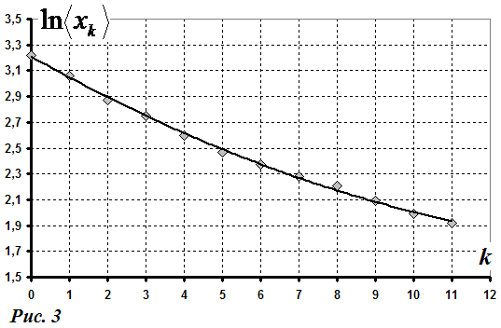

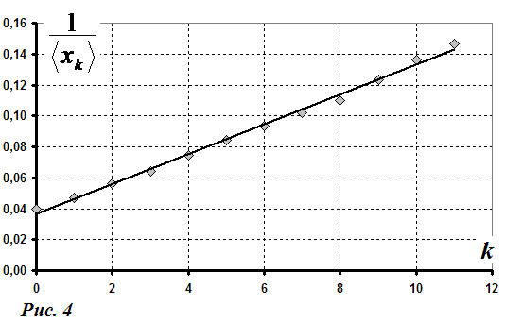
Dependence of $\frac{1}{\left\langle x_{k}\right\rangle }$ on $k$ is closer to linear, therefore, equation (6) describes experimental data

2.3 Since equation (6) follows from the quadratic dependence of the air resistance force on velocity, then the experimental data supports equation (2).

Part 3.

3.1 Results of measurement are shown in Table 3. The processing of the data follows the steps of Part 2.
$x_{k}$, cm | $$k$$ | $$k$$ | $$k$$ | $$\left\langle k\right\rangle$$ | $$\frac{1}{\left\langle x_{k}\right\rangle }$$ | $$\text{ln}\left\langle x_{k}\right\rangle$$
20 | 0 | 0 | 0 | 0,0 | 0,050 | 2,996
19 | 4 | 4 | 3 | 3,7 | 0,053 | 2,944
18 | 7 | 7 | 6 | 6,7 | 0,056 | 2,890
17 | 10 | 10 | 8 | 9,3 | 0,059 | 2,833
16 | 13 | 13 | 12 | 12,7 | 0,063 | 2,773
15 | 16 | 17 | 16 | 16,3 | 0,067 | 2,708
14 | 21 | 21 | 19 | 20,3 | 0,071 | 2,639
13 | 25 | 25 | 25 | 25,0 | 0,077 | 2,565
12 | 30 | 30 | 30 | 30,0 | 0,083 | 2,485
11 | 37 | 36 | 37 | 36,7 | 0,091 | 2,398
10 | 43 | 43 | 43 | 43,0 | 0,100 | 2,303
9 | 52 | 51 | 52 | 51,7 | 0,111 | 2,197
8 | 62 | 61 | 61 | 61,3 | 0,125 | 2,079
7 | 74 | 72 | 73 | 73,0 | 0,143 | 1,946

3.2 Графики зависимостей $\text{ln}\left\langle x_{k}\right\rangle$ (рис. 5) и $\frac{1}{\left\langle x_{k}\right\rangle }$ (рис. 6) от числа колебаний $k$ показывают, что и в данном случае формула (6) точнее описывает экспериментальные данные.
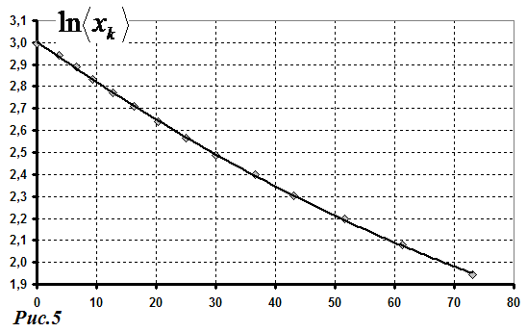

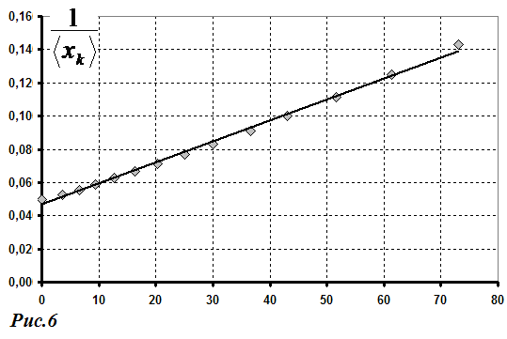

3.3 In this case quadratic dependence also describes the experimental situation better.
Marking scheme.

Item | Content | Points
1.1 | - loss power  - energy-velocity relation | 0,5  0,5
1.2 | - expression for the potential energy | 1,0
1.3 | Measurements:  - measurement range $x_{0}$ (from 25 to 10 cm);  - not less than 10 points;  Evaluation of $E_{0}$ and $ΔE$ for all points;  Plot (axes are signed and numbered, dots are plotted, smoothing curve is indicated) | 0,5  0,5  1  1
1.4 | Double logarithmic scale (or other linearization);  Evaluation of logarithms;  Plot (axes are signed and numbered, dots are plotted, smoothing curve is indicated);  Determination of the exponent (using all points) | 1  0,5  0,5  1
1.5 | Substantiated conclusion on the applicability of equation (2) | 1
2.1 | Measurements  - not less than 10 points;  - averaging; | 1,5  0,5
2.2 | Data processing to check to dependences:  - linearization;  - Plots of linearized curves;  - Conclusion on the applicability of equation (2) | 0,5+0,5  0,5+0,5  1
2.3 | Substantiated conclusion on the applicability of equation (2) | 1
3.1 | Measurements:  - range from 20 cm to 10 cm;  - not less than 10 points;  Plot (axes are signed and numbered, dots are plotted, smoothing curve is indicated) | 0,5  0,5  1
3.2 | - Plots of linearized curves;  - conclusion on the applicability of Eq. (6) | 1  1
3.3 | Substantiated conclusion on the applicability of equation (2) | 1

