SOLUTIONS FOR THEORETICAL COMPETITION

Theoretical Question 1
A block with an object
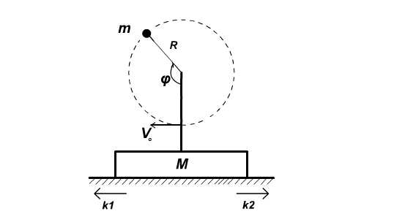
Fig.1

1. [1 point] From the energy conservation law for the object:
$V_{0^{2}}−V_{{\text{top}}^{2}}=4\text{gR}$$2V_{0}ΔV$, ${ΔV}/V=2{\text{gR}}/{V_{0^{2}}}$<<1
2. [2 point] Maximal angle of deviation of the floor’s total reaction force (Normal force + friction force) from vertical is
$α$ = arctg$μ$.
Denote

$T={{\text{mV}}_{0^{2}}}/R$, $ω={V_{0}}/R\text{.}$
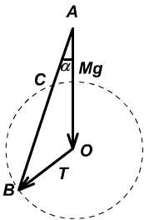

Fig.2

From the picture above we can see (see Fig.2) that the maximum angle of deviation of
$$M\vec{g}+\vec{T}$$
is $\text{arcsin}(T/{\text{Mg}})$ when $T≤\text{Mg}$ ($M\vec{g}+\vec{T}$is tangent to the circle). If the deviation angle of $M\vec{g}+\vec{T}$ from the vertical line is greater than $α$, then the equilibrium is impossible and the block will start to slide. The condition that we are looking for is
$$V_{0}^{\text{min}}=\sqrt{\frac{\text{MgR}μ}{m\sqrt{1+μ^{2}}}}$$

3. From Fig 2, the beginning of sliding corresponds to point B. The block accelerates on the portion of path BC, and decelerates afterwards.. Since the line intersects the rotation circle at two points, $∠\text{ABO}<π/2$, and therefore from the sine theorem for the triangle АВО :
$∠\text{ABO}$= arcsin(Mg$\frac{\text{sin}α}{{mω}^{2}R}$)= arcsin($\frac{μ\text{Mg}}{{mω}^{2}R\sqrt{1+μ^{2}}}$)
а) [1 point] Then
$ϕ_{0}$= $α$+$∠\text{ABO}$= arctg$μ$+ arcsin($\frac{μ\text{Mg}}{{mω}^{2}R\sqrt{1+μ^{2}}}$).
b) [1 point] Similarly
$ψ$= $α$+$π$-$∠\text{ABO}$= arctg$μ$+ $π$- arcsin($\frac{μ\text{Mg}}{{mω}^{2}R\sqrt{1+μ^{2}}}$).

4. To calculate the acceleration we can first decompose the forces into x and y components and write down Newton’s second law
F_{friction}=$μ$ N=$μ$(Mg +Tcos$ϕ$)
М a($ϕ$) = Tsin$ϕ$- F_{friction} = Tsin$ϕ$-$μ$(Mg +Tcos$ϕ$)
Тhen
V($ϕ$)=$\int{a(ϕ)\text{dt}=\int{\frac{a(ϕ)dϕ}{ω}}}$
Integration gives us:
V($ϕ$) = - ($\frac{T}{ωM}(\text{cos}ϕ+μ\text{sin}ϕ)+\frac{μgϕ}{ω}$)+($\frac{T}{ωM}(\text{cos}ϕ_{0}+μ\text{sin}ϕ_{0})+\frac{{μgϕ}_{0}}{ω}$).
a) [1point] Then
V_{max} = v($ψ$)=2$\frac{T}{ωM}\sqrt{1+μ^{2}−μ^{2}(\frac{\text{Mg}}{T})^{2}}$- $\frac{μg}{ω}(π−2\text{arcsin}$$\frac{μ\text{Mg}}{T\sqrt{1+μ^{2}}}$)
b) [1 point] The condition for $θ$ : V($θ$) = 0
$\frac{T}{ωM}(\text{cos}ϕ_{0}+μ\text{sin}ϕ_{0})+\frac{{μgϕ}_{0}}{ω}$=$\frac{T}{ωM}(\text{cos}θ+μ\text{sin}θ)+\frac{μgθ}{ω}$
5. The values are such that $\frac{\text{Mg}}{T}=\frac{1}{μ}$= 1/($\frac{π}{2}−1$).
a) [0.5 point] Using this equality we get :
$ϕ_{0}$= 90⁰ , $ψ$=90⁰ + 2arctg(0.57)150⁰, $θ=$180⁰
b) [0.5 point]
V_{max} = 2$\frac{μg}{ω}$($μ$-arctg$μ$)6*10⁻³m/s << $V_{0}$
c) [1 point] Displacement is
S=$\int{\frac{V(ϕ)dϕ}{ω}}$.
Plug in
$μ=\frac{π}{2}−1$,$ϕ_{0}=\frac{π}{2},θ=π$,
We get
S=($\frac{π}{2}−1$)(2+$\frac{π^{2}}{8}−π$)g/$ω^{2}$5.3*10⁻⁵m.
d) [1 point] The change in object’s velocity occurs because the kinetic energy is lowered due to work by friction force. In first nonvanishing order, the change in velocity is determined from the Law of change in energy, where the work of friction force is calculated assuming constant absolute velocity of the object:
${\text{mV}}_{0}ΔV=\int{F_{\text{friction}}\text{ds}=−\int_{ϕ_{0}}^{θ}{μ(\text{Mg +Tcos}ϕ)}}$v$(ϕ)\frac{dϕ}{ω}$.
By order of magnitude
$\frac{ΔV}{V_{0}}∝−\frac{μ\text{MgS}}{{\text{mV}}_{0^{2}}}∝−5∗{\text{10}}^{−4}$.
The exact value: -3*10⁻⁴

Theoretical Question 2
А
[5 points] Direct calculation of the current through resistance R is very complicated and takes a long time.
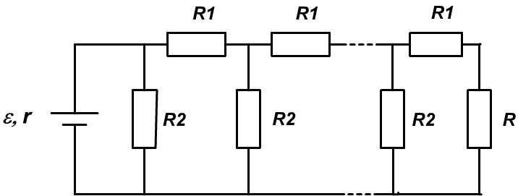

Fig.3

Therefore let’s first examine the Fig 4. Let current І flow through resistance R_{x}. Then the current through resistance R₂ will be
$$I_{2}=\frac{R_{x}+R_{1}}{R_{2}}I$$
Accordingly the current through the source is
$$I_{B}=\frac{R_{x}+(R_{1}+R_{2})}{R_{2}}I$$
The second rule of Kirchgoff for external contour is
$$\frac{R_{x}+(R_{1}+R_{2})}{R_{2}}I⋅r+I⋅(R_{1}+R_{x})=ε$$
From here we can find the value of current І, plugging in the values R₁ and R₂. Then
$$I=\frac{(2/3)ε}{(R_{x}+3)}$$
If we take into account that the internal resistance is r = 3 Ohms, we can write
$I=\frac{(2/3)ε}{R_{x}+3}=\frac{(2/3)ε}{R_{x}+r}=\frac{ε_{1}}{R_{x}+r}$,
In other words the circuit in Fig 4 is equivalent to the circuit in Fig. 5 where $ε_{1}=(2/3)ε$
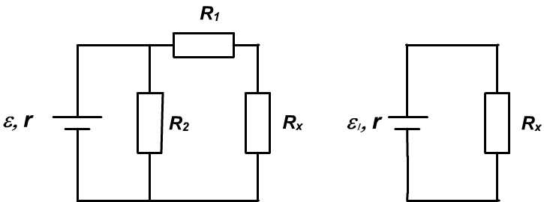

Fig.4 Fig.5

Then using this transformation 17 times we get the final result
$I=\frac{(2/3)^{\text{17}}ε}{R_{x}+r}=\frac{(2/3)^{\text{17}}⋅\text{10}}{\text{17}+3}=0,5⋅(2/3)^{\text{17}}=0,\text{0005}$ А

В
[3 points] Light goes through the lens, reflects form the mirror and goes through the lens again. Therefore, putting a flat mirror next to the lens is equivalent to putting an identical lens next to the first lens. The distance of the object from the single lens and from the lens-mirror system is the same. The absolute magnification is the same as well. Since Г = f/d, then absolute distance to the image is also the same(here f is the distance till the image, and d is the distance till the object). But the focal distance of the lens is twice as big as the focal distance of the lens-mirror system. It is easy to see that both images cannot be real at the same time or both virtual at the same time. Indeed, if both images are real, then
$Γ_{1}=\frac{F_{1}}{d−F_{1}}$; $Γ_{2}=\frac{F_{2}}{d−F_{2}}$
So Г₁ = Г₂ implies F₁ = F₂. The same would hold if both images were virtual. We are left with the only alternative that one image is real and the other is virtual. Since F₁>F₂ = F₁/2, the image produced by a single lens is virtual, and the image produced by lens-mirror system is real. (For a virtual image d < F, and for a real image d > F.) Тhen
$|Γ_{1}|=\frac{F}{F−d}$, $|Γ_{2}|=\frac{F/2}{d−F/2}$
Taking into account that |Г₁ |= |Г₂ | we get d = 2F/3, hence Г = 3.

Theoretical Question 3
Nuclear fusion
a) [1 point] In accordance with the Einstein formula the energy released in a single reaction is written as follows
$E_{0}=(m_{D}+m_{T}−m_{\text{He}}−m_{n})c^{2}=$ 2.973·10⁻¹² J.
b) [0.5 points] The same energy is written in electron-volts as follows
Е₀ = 2.973·10⁻¹²/1.6022·10⁻¹⁹ =1.856·10⁷ eV.
c) [1 point] If one can neglect the initial energies of reacting particles, the momentum and energy conservation laws immediately produce
$E_{n}=\frac{m_{\text{He}}}{m_{\text{He}}+m_{n}}=$2.375·10⁻¹² J = 1.482·10⁷ eV,
$E_{\text{He}}=\frac{m_{n}}{m_{\text{He}}+m_{n}}=$5.984·10⁻¹³J = 3.735·10⁶ eV.
d) [1 point] To overcome the Coulomb barrier nuclei should possess an appropriate thermal kinetic energy
.
Thus
.
e) [3 points] The reaction rate is given by an average over the Maxwellian distribution as follows
with the Maxwellian distribution function
.
Introducing the dimensionless value and substituting the latter expression into the previous one can obtain
.
The integrand function is drawn with the aid of the cross section figure as follows
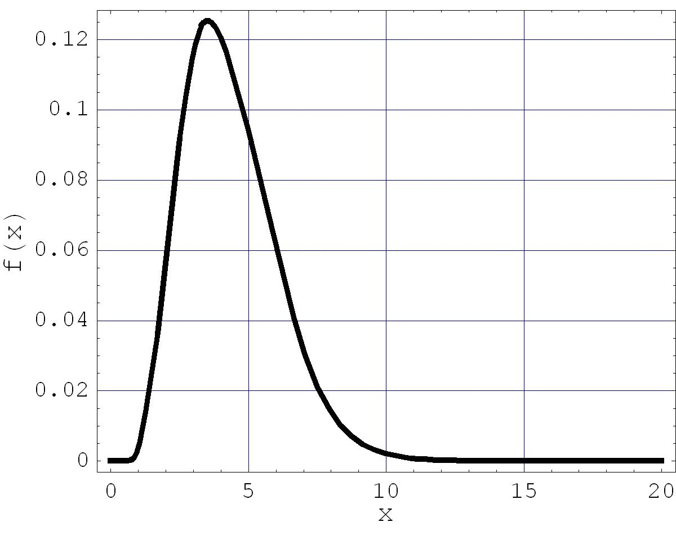
Estimating the area under the line gives
.
f) [3 points] Plasma consists of electrons and ions and loses its thermal energy at time . The effective power of losses in the unit of volume is given by the expression
.
This power should be less than that produced in fusion reactions (see e)
.
Thus,
.
This is the so-called Lawson’s criterion.
g) [2.5 points] Dimensional analysis immediately produces and . The thermal pressure of the plasma medium
should be compensated by the magnetic pressure from outside
.
Thus,
.

