THEORETICAL COMPETITION
January 16, 2007

Please read this first:

- The time available for the theoretical competition is 4 hours. There are three questions.
- Use only the pen provided.
- You are provided with Writing sheet and additional paper. You can use the additional paper for drafts of your solutions but these papers will not be checked. Your final solutions which will be evaluated should be on the Writing sheets. Please use as little text as possible. You should mostly use equations, numbers, figures and plots.
- Use only the front side of Writing sheets. Write only inside the bordered area.
- Begin each question on a separate sheet.
- Fill the boxes at the top of each sheet of paper with your country (Country), your student code (Student Code), the question number (Question Number), the progressive number of each sheet (Page Number), and the total number of Writing sheets used (Total Number of Pages). If you use some blank Writing sheets for notes that you do not wish to be evaluated, put a large X across the entire sheet and do not include it in your numbering.
- At the end of the exam, arrange all sheets for each problem in the following order:
- Used Writing sheets in order;
- The sheets you do not wish to be evaluated
- Unused sheets and the printed question.
Place the papers inside the envelope and leave everything on your desk. You are not allowed to take any paper out of the room.

Theoretical Question 1
A block with an object
A weightless rod is attached to a massive block with a mass M. An object with a mass m is attached to the rod by a weightless string of length R. The object can rotate in a vertical plane not touching the rod. The coefficient of friction between the block and the floor depends on the direction of sliding, k1=$μ$, k2 = $∞$. The object is launched with an initial velocity $V_{0}$ in the direction as shown in the picture 1. $V_{0}$ is sufficiently big so that the object makes at least one rotation around the rod.
In this problem you are asked to examine the movement of the system during the first rotation of the object. You can assume that the block does not detach from the floor and does not turn over and that the string is stretched while the object is moving. Let’s describe the position of the object by the angle$ϕ$ (Fig 1). Assume M>>m.

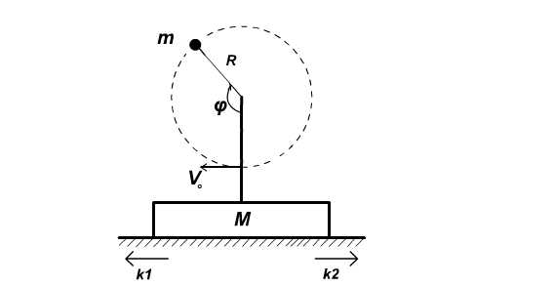
Fig.1

1. [1 point] In this part of the question assume that the parameters are such that the block does not move at all. Derive the condition that will guarantee that the change in absolute velocity of the object is considerably smaller than $V_{0}$in the process of rotation.
From this point onwards you can assume that the block’s velocity is considerably smaller than $V_{0}$, and that the change in absolute velocity of the object during first rotation is considerably smaller than $V_{0}$.
2. [2 points] Find the minimum initial velocity $V_{0}^{\text{min}}$which will cause the block to slide when the object is rotating.
3. For $V_{0}>V_{0}^{\text{min}}$ find:
а) [1 point] At which angle $ϕ_{0}$sliding will start;
b) [1 point] At which angle $ψ$ the velocity of block’s motion V will be largest.
4. а) [1 point] Find V_{max} which corresponds to the angle$ψ$ from b) above;
b) [1 point] Write down the condition for angle $θ$, at which the block stops.
5. Numerical data: $μ$ =$\frac{π}{2}−1$ 0.57,
g =10 m/s²,
M = 10 kg
$V_{0}$= 10 m/s,
R = 0.1 m,
m = 0.057 kg.
a) [0.5 points] Calculate$ϕ_{0}$,$ψ$ и $θ$.
b) [0.5 points] Calculate V_{max.}
c) [1 point] For the given numerical values, calculate the displacement of the block in one rotation of the object.
d) [1 point] In first non vanishing order, estimate the change in the velocity of the object at the lowest point after the first rotation in comparison to $V_{0}$.

Note:
The following formulas might be useful for solution:
cos$ϕ$+$μ$ sin$ϕ$= $\sqrt{1+μ^{2}}$cos($ϕ$-$α$),
cos$ϕ$-$μ$ sin$ϕ$= $\sqrt{1+μ^{2}}$cos($ϕ$+$α$),
where $α$ = arctg$μ$ = arccos(1/$\sqrt{1+μ^{2}}$) = arcsin($μ$/$\sqrt{1+μ^{2}}$).
$\int{\text{cos}ϕ}dϕ$=sin$ϕ$,$\int{\text{sin}ϕdϕ}$= -cos$ϕ$

Theoretical Question 2
This problem consists of two unrelated parts

А. [5 points]Find the current through resistance R = 17 Оhm, in the Fig 2. The internal resistance of the battery is r = 3 Ohm, Electromotive force ε = 10 V. The section with resistance R₁= 1 Ohm and R₂= 6 Ohm is repeated 17 times

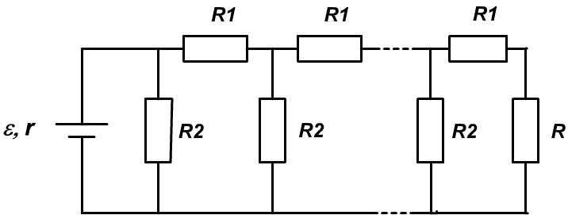

Fig.2

В. [3 Points] A thin lens creates the image of an object. If a flat mirror is put right next to this lens perpendicular to the main optical axis, then this whole system creates an image with the same absolute optical magnification as before provided that the object is at the same distance as before. Determine the magnification.

Theoretical Question 3
Nuclear fusion
One of the most important problems of modern plasma physics is the so-called controlled nuclear fusion. The most promising way of achieving the controlled nuclear fusion is the TOKAMAK, that is the magnetic trap for confining hot plasma.
The most perspective fusion reaction is based on hydrogen isotopes that are deuterium (D) and tritium (T) and it is symbolically written as
(1)
whereas the reaction products are the helium isotope and neutron .

a) [1 point] Assuming the particle masses are known, determine, analytically and numerically, the energy , released in a single fusion reaction (1).
b) [0.5 points] In nuclear physics the energy is frequently counted in electron-volts (eV). One electron-volt is the energy that a single electron acquires passing an accelerating voltage of one volt. Calculate, analytically and numerically, the energy, found in question a), in electron-volts.
c) [1 point] Neglecting the initial energies of reacting particles, determine, analytically and numerically, the amounts of energy taken away by the helium nucleus and the neutron .
d) [1 point] In Tokamaks the deuterium-tritium mixture is heated up to a very high temperature, such that all the atoms are fully ionized (such a state is called a plasma) and their average kinetic energy is equal to $(3/2)k_{B}T$. To make reaction (1) possible it is necessary to overcome the Coulomb repulsion of reacting nuclei and bring them close to a distance of where nuclei attraction forces prevail. Estimate, analytically and numerically, the temperature at which reaction (1) becomes possible for the majority of the colliding particles.
Fortunately, at thermal equilibrium the energies of particles are not even: some particles can have energy larger than $(3/2)k_{B}T$ while some might have less than $(3/2)k_{B}T$. Due to the presence of energetic particles the fusion reaction can take place even at temperatures lower than determined in d). The number of fusion reactions taking place per unit of time per unit of volume is given by the expression , where and are the deuterium and tritium concentrations, respectively, is the so-called cross section of the reaction, and refers to the relative velocity of the particles participating in the reaction.
e) [3 points] Determine, analytically and numerically, the average reaction rate at the temperature , assuming that the effective velocity distribution is Maxwellian with the reduced mass . The dependence of is graphically represented in the Fig.3 below.
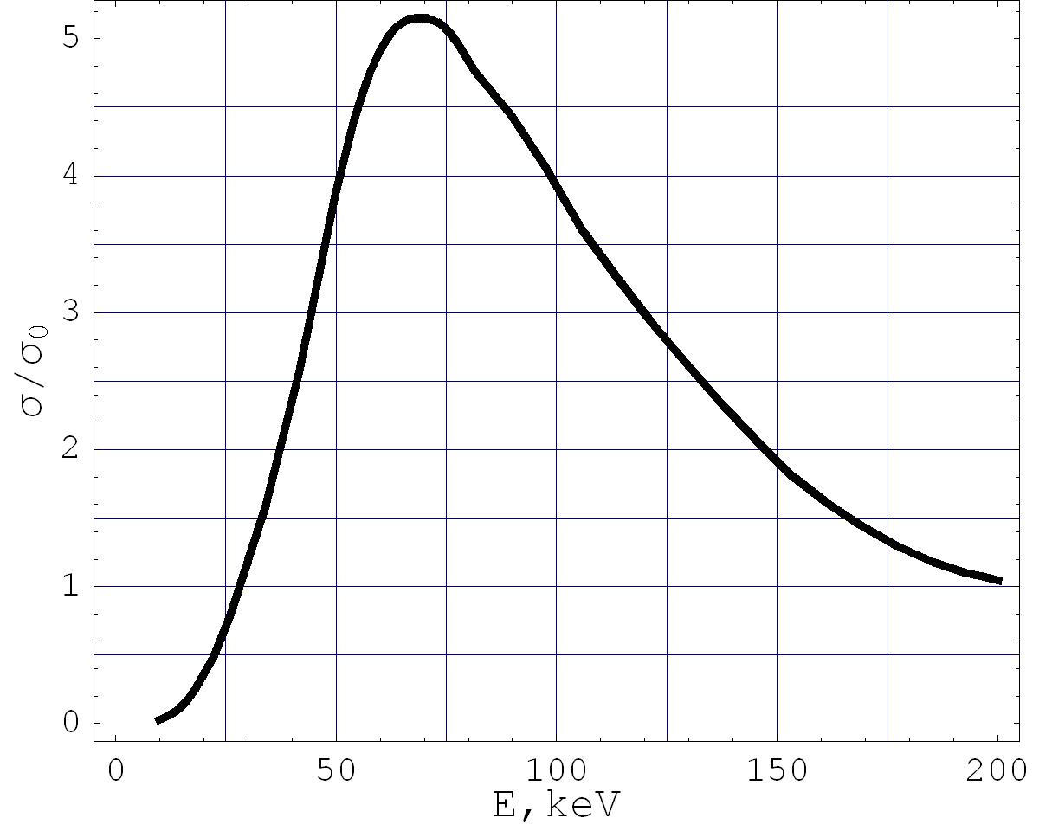
Fig.3. The cross section versus the relative energy of particles in the reaction expressed in .

f) [3 points] The matter heated to such a high temperature is in the state of plasma and the atoms are fully ionized. On the average, the total density of nuclei equals the density of electrons to satisfy the neutrality charge. To heat up the matter to the optimum temperature it is necessary to put in per unit of time a certain amount of energy, which should not exceed the amount released in fusion reactions. The energy of helium nucleus can totally be used for power production while only of the neutron energy can be utilized. The rate of loss of thermal energy is given by , where is the energy density and is the time of plasma retention. Assuming that the particle concentrations are , obtain, analytically and numerically, the inequality that guarantees the positive production of energy in a controlled nuclear fusion and relates the plasma concentration and retention time .
g) [2.5 points] The plasma with temperature has a quite high pressure for a simple wall to sustain. A magnetic field, generated by a superconducting electromagnets of Tokamaks, is used to confine such matter. Magnetic field is used to compensate the thermal pressure. In the presence of magnetic field, the additional pressure due to magnetic field is , where , is the magnetic constant and is the magnetic field. Magnetic field is completely screened inside the plasma, so the additional pressure is absent there. Using dimensional analysis, find and and determine, analytically and numerically, the magnetic field needed to confine the plasma with .
Numerical values:
Mass of deuterium $m_{D}=3\text{.}\text{34447}⋅{\text{10}}^{−\text{27}}\text{kg}$,
Маss of tritium $m_{T}=5\text{.}\text{00732}⋅{\text{10}}^{−\text{27}}\text{kg}$,
Мass of helium $m_{\text{He}}=6\text{.}\text{64432}⋅{\text{10}}^{−\text{27}}\text{kg}$,
Мass of neutron $m_{n}=1\text{.}\text{67439}⋅{\text{10}}^{−\text{27}}\text{kg}$,
Speed of light $c=2\text{.}\text{9979}⋅{\text{10}}^{8}m/s$,
Elementary charge $e=1\text{.}\text{6022}⋅{\text{10}}^{−\text{19}}C$,
Boltzmann constant $k_{B}=1\text{.}\text{3806}⋅{\text{10}}^{−\text{23}}J/K$,
Electric constant $ε_{0}=$8.854·10⁻¹² F/m,
Magnetic constant $μ_{0}=$1.257·10⁻⁶ H/m.

Note:
The Maxwell distribution of the particle velocities with mass $μ$ and temperature T has the following density function:

