Solutions of the experimental task

1. [1 point] Let’s examine the relationship between resistance of the thermoresistor and temperature based on the following setup
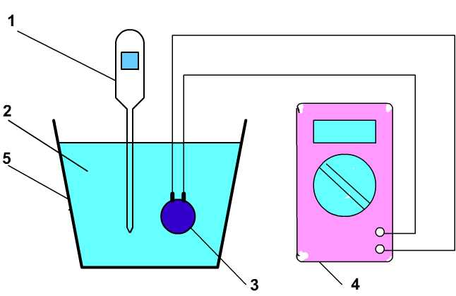
Here: 1 – digital thermometer; 2 – distilled water; 3 – thermoresistor; 4 – digital multimeter; 5 – glass.

2. [3 points] The relationship between resistance R of the thermoresistor and temperature tºC

Table №1
N | t, ºC | R, Ohm
1  2  3  4  5  6  7  8  9  10  11 | 80,0 ± 0,1  75,0 ± 0,1  70,0 ± 0,1  65,0 ± 0,1  60,0 ± 0,1  55,0 ± 0,1  50,0 ± 0,1  45,0 ± 0,1  40,0 ± 0,1  35,0 ± 0,1  30,0 ± 0,1 | 15,6 ± 0,1  17,4 ± 0,1  19,5 ± 0,1  22,0 ± 0,1  25,3 ± 0,1  29,2 ± 0,1  34,3 ± 0,1  40,6 ± 0,1  48,5 ± 0,1  57,3 ± 0,1  71,2 ± 0,1

3. [3 points] The expression
$$σ=σ_{0}\text{exp}\left\{−\frac{ΔW}{2\text{kT}}\right\}$$
сan be linearized, if we take the logarithm of both sides:
$$\text{ln}σ=\text{ln}σ_{0}−\frac{ΔW}{2\text{kT}}$$
Therefore
$$\text{ln}σ=−\frac{ΔW}{2k}\frac{1}{T}+\text{ln}σ_{0}$$

4. [2 points] The values that we need are as follows:
Table №2
N | t,ºC | 1/T, K⁻¹ | R, Оhm | σ = 1/R, Ohm⁻¹ | ℓn (σ Ohm)
1  2  3  4  5  6  7  8  9  10  11 | 80,0  75,0  70,0  65,0  60,0  55,0  50,0  45,0  40,0  35,0  30,0 | 0,00283  0,00287  0,00292  0,00296  0,00300  0,00304  0,00309  0,00314  0,00319  0,00324  0,00330 | 15,6  17,4  19,5  22,0  25,3  29,2  34,3  40,6  48,5  57,3  71,2 | 0,0641  0,0575  0,0513  0,0455  0,0395  0,0342  0,0292  0,0246  0,0206  0,0175  0,0140 | – 2,75  – 2,86  – 2,97  – 3,09  – 3,23  – 3,38  – 3,53  – 3,71  – 3,88  – 4,05  – 4,27

5. [3 points] Below is the graph of ℓn σ versus 1/Т, using ordinary least squares:
6. [3 points] According to the result in 5)
a) The slope of the linear relationship is 3,27∙10³K. Then
$\frac{ΔW}{2k}=$3,27∙10³K
Then the width of the forbidden zone is
∆W = 3,27∙10³∙2∙k = 3,27∙10³∙2∙1,38∙10⁻²³J = 0,90∙10⁻¹⁹ J = 0,56 eV
The uncertainty is
(∆W) = 0,06∙10³∙2∙k = 0,06∙10³∙2∙1,38∙10⁻²³ = 0,02∙10⁻¹⁹ J = 0,01 eV
- свободный член уравнении равняется 6,6. Тогда
$$\text{ln}(σ_{0}\text{Ом})=6,6$$
и значение $σ_{0}$ равняется
$σ_{0}=$1,87 Ом⁻¹
Соответственно погрешность
${Δσ}_{0}=$0,37 Ом⁻¹
Finally
ΔW = (0,56±0,01) eV
$σ_{0}=$(1,87±0,37) Ом⁻¹

