EXPERIMENTAL COMPETITION
17 January, 2007

Please read the instructions first:

- The Experimental part consists of one problem. This part of the competition lasts 3 hours.
- Please only use the pen that will be given to you
- You are provided with Writing sheet and additional papers. You can use the additional paper for drafts of your solutions but these papers will not be checked. Your final solutions which will be evaluated should be on the Writing sheets. Please use as little text as possible. You should mostly use equations, numbers, figures and plots.
- Use only the front side of Writing sheets. Write only inside the bordered area.
- Begin each question on a separate sheet.
- Write on the blank writing sheets whatever you consider is required for the solution of the question.
- Fill the boxes at the top of each sheet of paper with your country (Country), your student code (Student Code), the question number (Question Number), the progressive number of each sheet (Page Number), and the total number of Writing sheets (Total Number of Pages). If you use some blank Writing sheets for notes that you do not wish to be evaluated, put a large X across the entire sheet and do not include it in your numbering.
- At the end of the exam, arrange all sheets for each problem in the following order:
- Used Writing sheets in order;
- The sheets you do not wish to be evaluated
- Unused sheets and the printed question.
Place the papers inside the envelope and leave everything on your desk. You are not allowed to take any paper out of the room

Determining the width of the forbidden zone of a semiconductor

Gadgets and materials: Digital multimeter, digital thermometer, thermoresistor, a glass of distilled water (water is given at the request of the competition participant), skotch, napkins, plotting paper.

We know that electric conductivity of semiconductors σ, grows fast as temperature changes, according to the law
$σ=σ_{0}\text{exp}\left\{−\frac{ΔW}{2\text{kT}}\right\}$ (1)

where $ΔW$ - the width of the forbidden zone, k = 1,38·10⁻²³ J/K – Boltzmann constant, Т –absolute temperature. In this experimental problem you are asked to determine the width of the forbidden zone of a semiconductor thermoresistor, using the law shown above.

The task for the experimental part (15 points):
Investigate the resistance of the thermoresistor in the 30C-80C temperature range. Determine the width of the forbidden zone $ΔW$, the parameter $σ_{0}$ and evaluate the uncertainties.
Attention: Be cautious with hot water!

Appendix

INSTRUCTIONS FOR DIGITAL MULTIMETER

FRONT PANEL DESCRIPTION
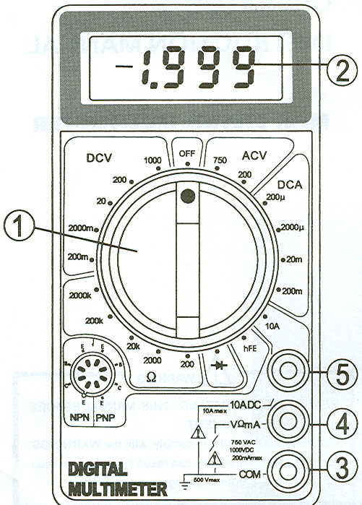
1. FUNCTION AND RANGE SWITCH. This swish is used to select the function and desired range as well as to turn on the instrument. To extend the life of this battery, the switch should be in the “OFF” position when the instrument is not is use.
2. DISPLAY
3. “COMMON” JACK. Plug in connector for black (negative) test lead.
4. “VΩmA” JACK. Plug in connector for red (positive) test lead for all voltage and resistance and current (except 10 A) measurements.
5. “10 A” JACK. Plug in connector for red (positive) test lead for 10 A measurement.

DC VOLTAGE MEASUREMENT
1. Connect red test lead to “VΩmA” jack. Black lead to “COM” jack.
2. Set RANGE switch to desired DCV position. If the voltage to be measured is not known beforehand, set switch to the highest range and reduce it until satisfactory reading is obtained.
3. Connect test leads to device or circuit being measured.
4. Turn on power of the device or circuit being measured, voltage value will appear on Digital Display along with the voltage polarity.
AC VOLTAGE MEASUREMENT
- Red lead to “VΩmA”. Black lead to “COM”.
- RANGE switch to desired ACV position.
- Connect test leads to device or circuit being tested.
- Read voltage value on Digital Display.

DC CURRENT MEASUREMENT
- Red lead to “VΩmA”. Black lead to “COM”. (For measurements between 200 mA and 10 A connect red lead to “10 A” jack with fully depressed.)
- RANGE switch to desired DCA position.
- Open the circuit to be measured, and connect test leads IN SERIES with the load in which current is to be measured.
- Read current value on Digital Display.

RESISTANCE MEASUREMENT
- Red lead to “VΩmA”. Black lead to “COM”.
- RANGE switch to desired Ω position.
- If the resistance being measured is connected to a circuit, turn off power and discharge all capacitors before measurement.
- Connect test leads to circuit being measured.
- Read resistance value on Digital Display.

STRAIGHT LINE FIT USING THE LEAST SQUARES METHOD

Be y = аx + b the least squares regression fit obtained by this method. Then:
$a=\frac{\sum_{i}^{n}{x_{i}}\sum_{i}^{n}{y_{i}}−n\sum_{i}^{n}{x_{i}y_{i}}}{{\left(\sum_{i}^{n}{x_{i}}\right)}^{2}−n\sum_{i}^{n}{x_{i}^{2}}}$ $b=\frac{\sum_{i}^{n}{x_{i}}\sum_{i}^{n}{x_{i}y_{i}−\sum_{i}^{n}{y_{i}}\sum_{i}^{n}{x_{i}^{2}}}}{{\left(\sum_{i}^{n}{x_{i}}\right)}^{2}−n\sum_{i}^{n}{x_{i}^{2}}}$

$Δa=\sqrt{\frac{{nσ}^{2}}{n\sum_{i}^{n}{x_{i}^{2}}−{\left(\sum_{i}^{n}{x_{i}}\right)}^{2}}}$ $Δb=\sqrt{\frac{σ^{2}\sum_{i}^{n}{x_{i}^{2}}}{n\sum_{i}^{n}{x^{2}}−{\left(\sum_{i}^{n}{x_{i}}\right)}^{2}}}$

⬧ can be given as $σ=\sqrt{σ_{y}^{2}+a^{2}σ_{x}^{2}}$, with $σ_{x}=\sqrt{\frac{\sum_{i}^{n}{{Δx}_{i}^{2}}}{n}}$ and $σ_{y}=\sqrt{\frac{\sum_{1}^{n}{{Δy}_{i}^{2}}}{n}}$ where x_{i} and y_{i} are the individual uncertainties of the n independent measurements.

