Sources

6th International Geography Olympiad

Brisbane

June 2006

Contents of sources
page

Section 1 Climate | 3
Section 2 The dynamics of population: migration | 6
Section 3 Volcano Merapi | 7
Section 4 Economic activity, the business world and Global Shift | 9
Section 5 Fresh water in the Middle East | 10

Source 2

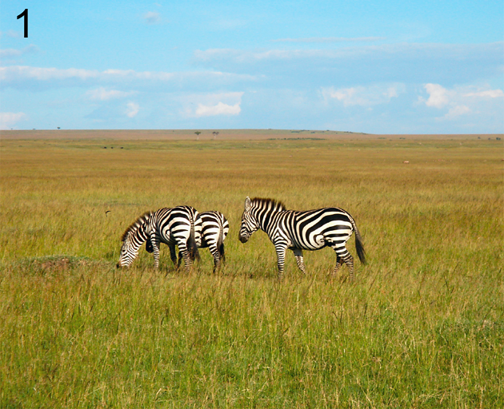 | 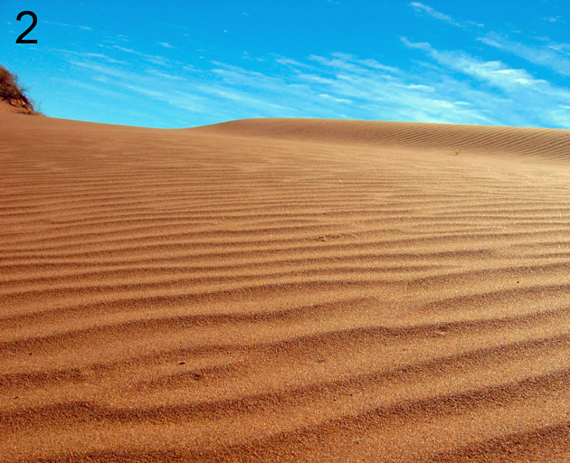
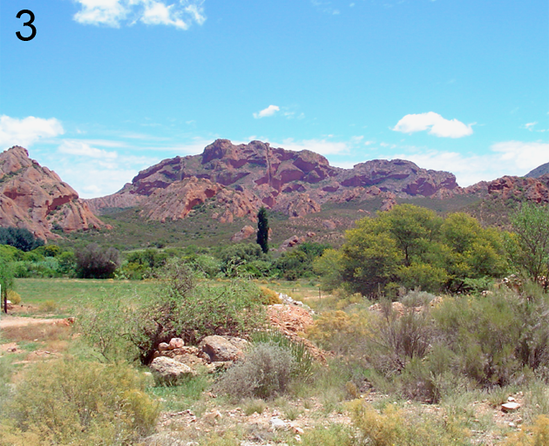 | 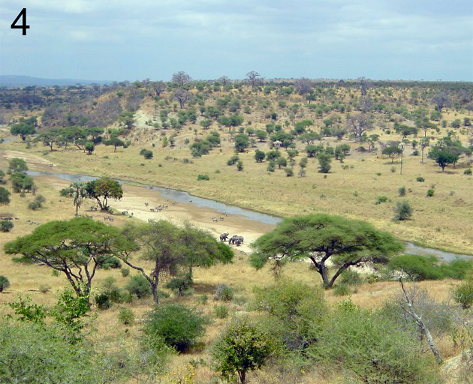

Source 3

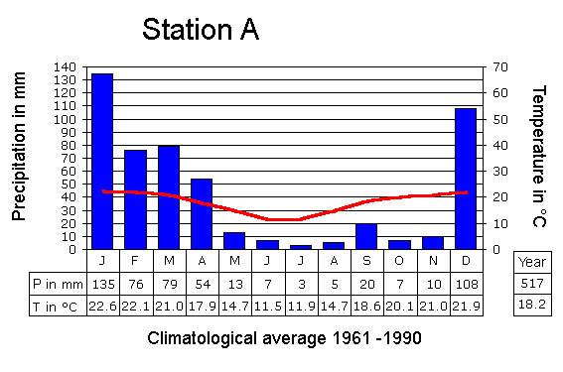

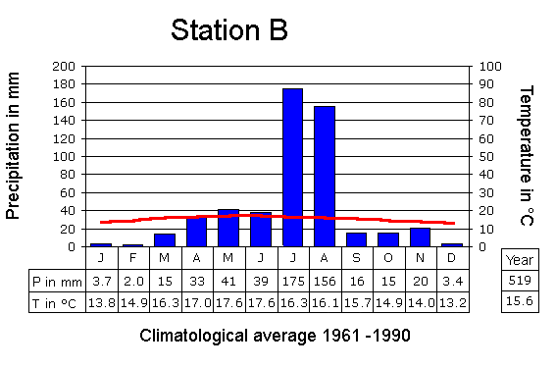

Section 2: The dynamics of population: migration

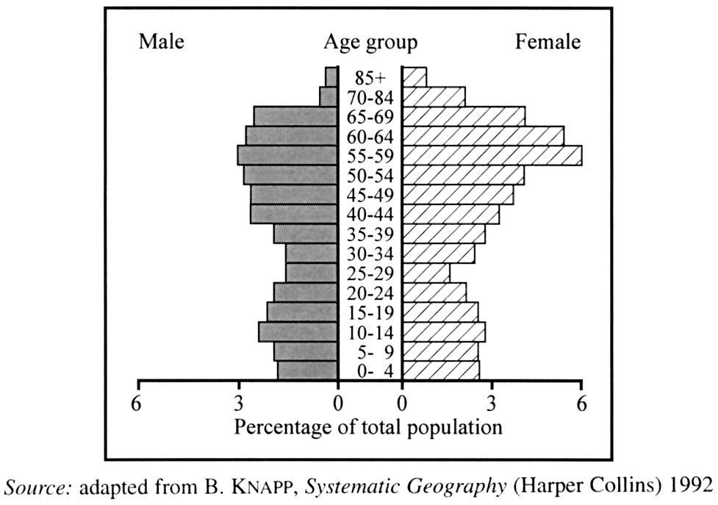

Section 3: Volcano Merapi

Source 1

Merapi's activity climbs in wake of quake
Slamet Susanto, The Jakarta Post, Yogyakarta, May 30, 2006.
A volcanologist warned Monday that Mount Merapi's activity level had tripled in the wake of Saturday's catastrophic earthquake in Bantul near Yogyakarta, Central Java. Mr.A.Ratdomopurbo said an eruption was still possible following the quake -- measuring 5.9 on the Richter scale according to the Meteorology and Geophysics Agency -- after the volcano expelled more hot clouds of ashes and gas which reached farther distances. "The quake in Bantul clearly affected Merapi's activities. Since the quake, the volcano has discharged hot clouds three times more than usual," the chief of the Yogyakarta-based Volcanological Research and Technology Development Center told The Jakarta Post. The volcano, which has been rumbling and spewing smoke and lava for weeks, only expelled 45 hot clouds on Friday, but the number rose to 54 on Saturday and then jumped to 159 on Sunday. "The increase might have happened because the lava dome was shaken, opening up a new way for the hot clouds (to be released)," Ratdomopurbo said. International volcanology experts were divided about whether the earthquake and the volcano's heightened activity were related.
The increased activity, he added, also was marked by a higher number of tremors, from 29 recorded a day before the quake to 237 on Sunday. On Monday, in the period from midnight to 6 a.m., over 85 tremors had been recorded at the mountain. Ratdomopurbo was unsure of the impact of Saturday's quake on the volcano's two lava cauldrons -- one located at 1.5 kilometres deep and the other 6 kilometres deep. "We can't detect it because they are located deep under the surface. What we can observe is the increase in activity of its hot clouds," Ratdomopurbo said. He predicted it would expel bigger hot clouds, with the greatest danger posed by an eruption due to high temperatures and toxic gases. The clouds -- which can reach temperatures of 1,000 degrees Celsius at the crater and 400 degrees Celsius by the time they reach communities on the volcano's slopes -- killed 50 people during a 1994 eruption.
Source: www.thejakartapost.com [article has been shortened and slightly adapted]

Source 2 Indonesia and the Merapi

Section 4: Economic activity, the business world and Global Shift

Source 1

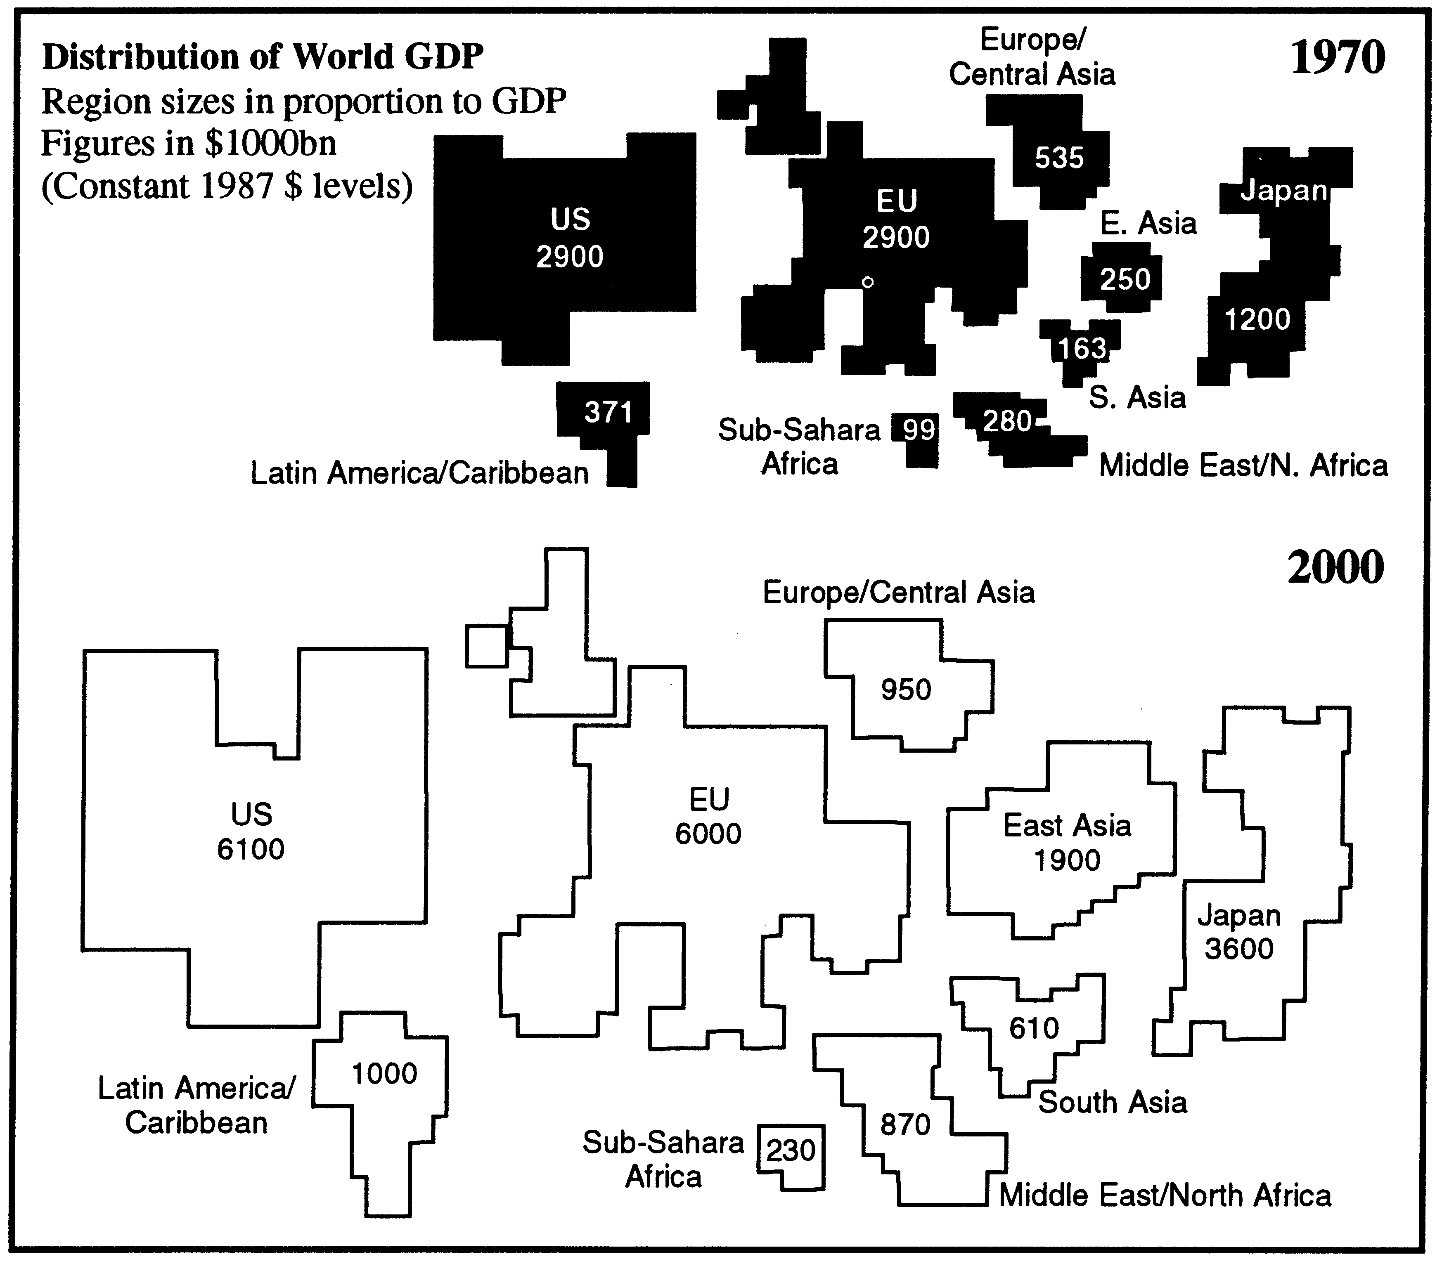

Section 5: Fresh water in the Middle East

Source 1 Precipitation in the Middle East

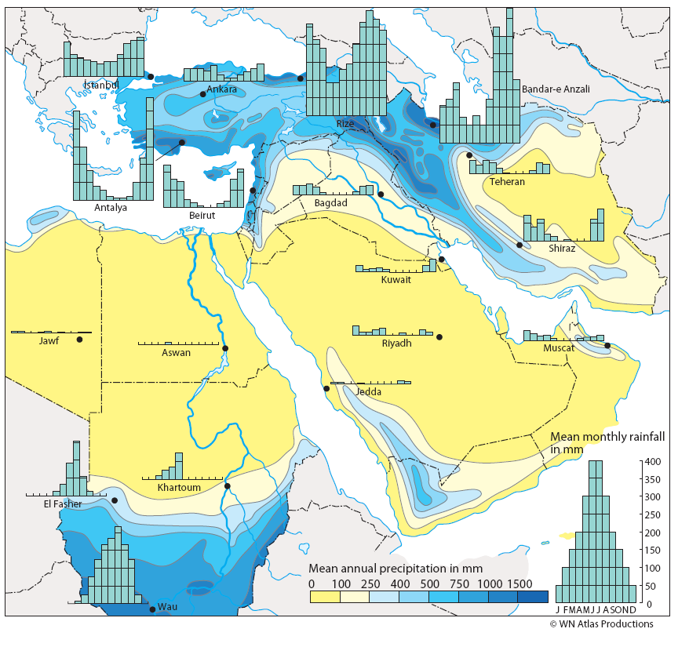

Source 2 Water between Turkey and the Gulf Region

