Questions

6th International Geography Olympiad

Brisbane

June 2006

Contents
page

Instructions for the students | 3
Section 1 Climate | 4
Section 2 The dynamics of population: migration | 6
Section 3 Volcano Merapi | 8
Section 4 Economic activity, the business world and Global Shift | 10
Section 5 Fresh water in the Middle East | 14

Instructions for the students

- This test consists of five sections.
1 Climate 18 marks
2 The dynamics of population: migration 19 marks
3 Volcano ‘Merapi’ 15 marks
4 Economic activity and the business world 18 marks
5 Fresh water in the Middle East 20 marks
- The total of all marks is 90

- Give only the required number of answers (reasons, examples et cetera). For instance, if the question asks for two reasons and you give more than two, only the first two reasons will be marked.

- Answer all questions on your answer sheets or worksheets.
Use a new answer sheet for each sections (1 - 5).

- Write your name and country on each of the five answer sheets and the four worksheets.
- The Sources booklet contains the maps and figures referred to in the questions.

- Time available: 150 minutes.
Non-native speakers of English are allowed an additional 30 minutes.

- Non-native speakers of English are allowed to use dictionaries: English - native language and native language - English.

Success!

Section 1 Climate

Weather in the world

Look at Source 1 which is worksheet 1.
Write your name and country on worksheet 1.

1a In what time of the year (month) was this satellite image taken? (1m)
1b Justify your choice by using information on this image. (2m)

2a Mark the Inter Tropical Convergence Zone (ITCZ) by drawing two (2) lines on the world map on worksheet 1. (1m)
2b How can this zone be identified on the map. (1m)
Write down the three (3) atmospheric processes that take place in this zone. (2m)

3a Draw a circle on the image on worksheet 1 to indicate
- one (1) low pressure area (with a L) (1m)
- one (1) high pressure area (with a H) (1m)
3b Justify your choice for the area of high pressure. (1m)

Pressure areas in the world

4 The subtropical zone of high pressure in the Southern Hemisphere is much more distinct than the same kind of zone in the Northern Hemisphere.
Explain why. (2m)

Climates and type of vegetation in Africa (sources 2 and 3 of Section 1)

There are four images (1 - 4) that show the natural vegetation of four African regions There are also two climate graphs (A and B) of two climate stations in Africa.

5 The climate graphs match two of the four vegetation images. What is the type of vegetation that is related to:
- climate station A? (1m)
- climate station B? (1m)

6 Justify your answer to the following.
- A and image … : because … (1m)
- B and image … : because … (1m)

7 Write your name and country on worksheet 2.
Clearly show the location of the climate stations by writing the letters A and B on the map of Africa. (2m)

Section 2 The dynamics of population: migration

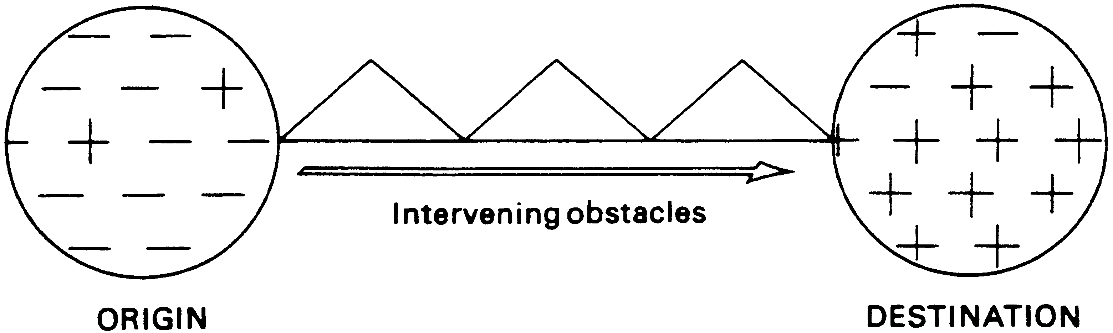

The figure above is a schematic representation of Lee’s model of The Decision to Migrate (1966).

1a What is the significance of the plus and minus signs in the circles symbolising regions of origin and destination of migrants? (2m)

1b Name three (3) factors that might be regarded as ‘intervening obstacles’. (3m)

1c With reference to the model above, describe two (2) reasons why a person would choose NOT to migrate. (2m)

1d Using the terms used in the model, outline the major differences between PUSH and PULL migration. (4m)

Refer to the source in Section 2 of the booklet.
This figure shows a population structure greatly influenced by migration. Some towns or regions within countries of the more economically developed world have this type of population structure.

2a Name two (2) factors other than age, that make migration a selective process. (2m)

2b Does this population structure belong to a town or region with a positive balance of migration or with a negative balance of migration?
Explain your choice. (2m)

2c If the population structure shown in the source resulted from a positive balance of migration, name two (2) possible economic benefits for this town or region. (2m)

3 Name two (2) disadvantages that migrants might experience in their new country. (2m)

Section 3 Volcano Merapi

The inhabitants of the Indonesian island of Java were alarmed last May by an earthquake that caused considerable damage in the region around the city of Yogyakarta.
Not far away from Yogyakarta the volcano Merapi has been spewing gas and ashes for several weeks. Experts hold different views about the connection between the two geological phenomena.

Read the article from The Jakarta Post of May 30, 2006 (Section 3, source 1). Study the other sources in Section 3 and answer the following questions.

In source 3, letter ‘A’ indicates the place where the effects of the earthquake were strongest.
1a Which geographical term is used to describe place A? (1m)
1b Which geographical term is used to describe the underground seismic centre of the earthquake. (letter B in source 4)? (1m)

The earthquake was not extremely strong, yet the number of victims was relatively high.
2 Explain two (2) factors that contributed to the relatively high number of victims. (2m)

Write your name and country on worksheet 3.
Java is located on the edge of two geological plates. The cross section of source 4 shows only the upper part of the plates. This same cross section is shown on worksheet 3.
Complete the cross section by drawing the lower parts in the white space.
In your answer:
3a Draw the path of both plates in the underground. (1m)
3b Draw two (2) circles indicating the magma chambers mentioned in
source 1. (1 m)
3c Write the following terms in the correct place in the cross section: (1m)
- continental plate
- oceanic plate
- Java Trench
3d Draw two (2) arrows indicating the direction in which both plates move.
(1m)

Worksheet 3 ‘Volcano Merapi’ contains a map of the island of Java and the surrounding sea.
4 Draw a line on this map (source 2) indicating the path of the boundary between the oceanic and the continental plates. (1m)

5 Explain why both volcanism and earthquakes occur on the island of Java. (2m)

The nature of volcanism on Java is quite different from volcanism on Iceland. On Java granitic magma is found whereas Iceland has basaltic magma.
6a Use the words ‘high’ and ‘low’ to complete the columns ‘basaltic magma’ and ‘granitic magma’ in the table on worksheet 3. (3m)
6b Based on the properties of the Merapi magma, would an eruption be explosive or quiet? (1m)

Section 4 Economic activity, the business world and

Global Shift

There has been considerable economic growth in that area of the world known as the Pacific Rim. This growth is expected to continue.

1 Outline what the term Pacific Rim means in this context. (2m)

Refer to Section 4 source 1.
2 Use the information from the figure to show how there is expected to be an increase in the relative importance of the Pacific Rim within the world economy between 1970 and 2000. (2m)

3 With reference to East and South Asia, give three (3) reasons for their growing importance in industry and business. (3m)

4a For any country in the developed world, give three (3) reasons which help to explain the declining employment in manufacturing industry in the last forty years. (3m)

4b Name three (3) ways in which governments in the developed world have reacted to such a trend. (3m)

5a Give one (1) social, one (1) economical and one (1) political reason why some countries of the North supply foreign aid to some countries of the South. (3m)

5b Name two (2) benefits of foreign aid for the countries of the South. (2m)

Section 5 Fresh Water in the Middle East

Refer to the map ‘Precipitation in the Middle East’ - Section 5, source 1.

Precipitation in the northern part of the Middle East shows a distinct seasonal pattern.
1a In what season is precipitation the lowest? (1m)
1b Explain your answer. (2m)

Refer to map ‘Water between Turkey and the Gulf Region’ - Section 5, source 2.
Approximately 20% of the irrigated land in Iraq is no longer suitable for agriculture as a result of inappropriate methods of irrigation.
2a Describe an inappropriate method of irrigation that has a negative impact on the soil. (2m)
2b Provide two (2) specific measures that could stop or reverse this process. (2m)

In several dry regions of the Middle East natural reservoirs of groundwater occur. The capacity of a groundwater reservoir depends on the nature of the rock formation
3a Which of the following rock formations has the highest capacity? (1m)
- shale
- sandstone
- granite
- limestone
3b Explain your answer. (1m)

4 Write your name on worksheet 4 ‘Fresh Water in the Middle East.
There are different principles that can be used in dividing river water rights between countries. The table in worksheet 4 lists a number of these principles.
Analyse the situation for the river Euphrates and the countries Turkey, Syria and Iraq.
For each principle indicate in column A which country would benefit, and in column B which country would be disadvantaged. (4m)

5a Compare principles 1 and 2. Both are geographical in nature.
Mention two (2) reasons why principle 2 is to be preferred to
principle 1. (2m)
5b Compare the principles 4 to 8. Mention one (1) of these principles that, in your opinion, should be included in negotiations over water rights between states. Justify your choice. (3m)

The Greater Anatolian Project consists of a number of dams and artificial lakes in the river Euphrates in the South East of Turkey. It stimulates large scale irrigated agriculture.
It is to be expected that both the quantity and the quality of the water downstream will be affected.

6 Explain in what way(s) irrigation in South East Turkey can negatively influence the quality of the river water of the Euphrates. (2m)

