MULTIMEDIA TEST
Brisbane 2006

Instructions:

Look at the PowerPoint slides and read the questions carefully. We will also read the questions for you.

Depending on the complexity of the question we will give you 30 to 90 seconds for a question.

This multimedia test has 30 questions.

Every question is multiple choice.
Choose A, B, C or D.
Only one answer is correct.

Mark your choice with a circle around the letter that you want to select.
Do that by making a circle around the selected letter:

A

If you make a mistake delete the selected letter:

A

and make a new choice:

B

Good luck!

1. Here are three photographs. They were all taken in the same country. Look carefully. In which one of the following countries were they taken? We will show you all the photographs two times.

A Senegal
B Egypt
C Iran
D Jordan

2. Here are three photographs. They were all taken in the same country. Look carefully. In which one of the following countries were they taken? We will show you all the photographs two times.

A Italy
B Norway
C Portugal
D Belarus

3. This photograph was taken in a capital city located near 10 degrees East. The next Olympiad will be in this city. Which two cities are located at the same longitude as the city in the photograph?

A Hamburg and Libreville
B St. Petersburg and Kigali
C Baku and Samara
D London and Accra

4. This photograph from Dubai illustrates:

A Global warming
B The greenhouse effect
C Increasing air traffic
D Globalization

5. The map shows:

- The distribution of global migration in the late 1990s.
- The distribution of global air cargo in the late 1990s.
- The distribution of global oil transport in the late 1990s.
- The distribution of global internet traffic in the late 1990s.

6. The table shows life expectancy at birth in some countries in Southeast Asia.
One name is missing. Which country is it?

- Laos
- Myanmar
- Vietnam
- Malaysia

7. The figure shows characteristics of a country in the southern hemisphere.
Which country is this?

A. Argentina
B. Cuba
C. Nigeria
D. Republic of South Africa

8. If you fit these two pieces of land together you will make the shape of:

- Chile
- Somalia
- Norway
- Peru

  - What is the name of the country coloured dark green on the map?

- Cameroon
- Angola
- Gabon
- Guinea

10. On this photo you see an impressive view of the 2002 Etna eruption from the International Space Station, possibly one of the most spectacular existing photos of this eruption.
Besides the ongoing activity, the photo very neatly shows:

A The effect of the wind on the direction of the eruption.
B The distance between the Etna and other Italian volcanoes like the Stromboli.
C The catastrophe caused by this eruption for the people living in Sicily.
D Lava flows of various ages on the flanks of the volcano: darkest are most recent

11. Compare the Google Earth map with the photo.
In which direction was the photo taken?

- Northwest
- Northeast
- Southeast
- Southwest

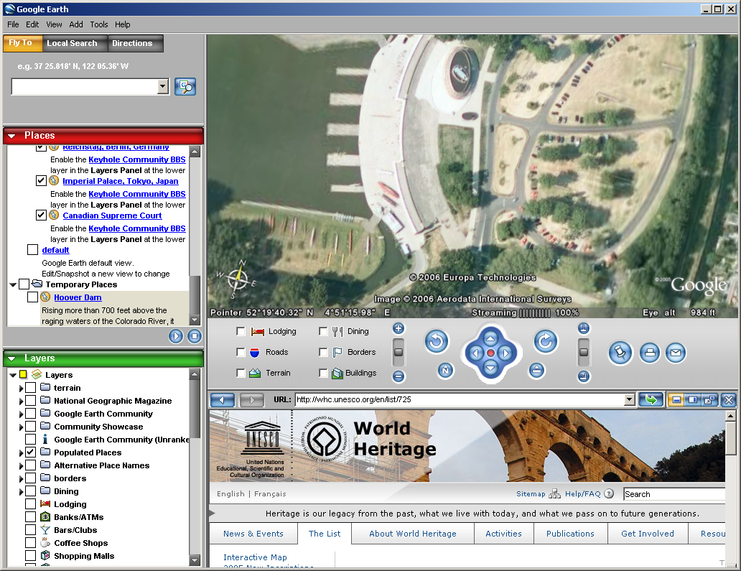

12. The photo shows a huge dam generating hydro-electricity.
Three countries where you find this kind of huge dam are:
A. India, Japan and Bangladesh
B. Denmark, Spain and Chile
- Brazil, Russia and China
- Estonia, Egypt and the United States

13. The photo shows a border between two countries.
The most heavily fortified border in the world exists between:

- Finland and Russia
- India and Pakistan
- North Korea and South Korea
- Syria and Lebanon

14. Which city would be LEAST likely to be threatened by a tsunami?

- Honolulu, United States
- Manila, Philippines
- Tokyo, Japan,
- Bogotá, Colombia

15. Here are three photographs.
We will show you all the photographs two times.
All the photos were taken in or near the same city.
The city is located north of the Equator.
What is the name of the city?

A. Glasgow
B. Sydney
C. Valparaiso
D. Bern

16. Look at photo A. You see a country that has approximately 125 million inhabitants.
If you go from the capital of this country 9000 kilometres east you are near the city that you see at photo B.
This city has a low population density compared to other large cities.
What is the city of photo B?

- New York
- Mexico City
- Los Angeles
- Vancouver

17. The photo is taken in the capital of a country.
The country has 32 million inhabitants and a king.
The capital is situated on the same latitude as Los Angeles and Osaka.
What is the name of the city?

A Teheran
B Cairo
C Rabat
D Alexandria

18. Look at the satellite photo of Antarctica.
What are the names of the countries that claim the largest amount of land mass on Antarctica?

- Norway and Australia
- Russia and the United States
- Argentina and Chile
- United Kingdom and France

19. Where can you find the biggest amount (90%) of fresh water on our planet?

A. in the Caspian Sea
B. on Greenland
C. in the Great Lakes in the USA
D. on Antarctica

20. A 12 year old boy drew a map of his country. Where does this boy live?

A. in Morocco
B. in Egypt
C. in India
D. in Somalia

21. Here are two photographs. We will show you the photographs two times. Which statement is correct?

A Photo 1 is a steppe landscape in Congo and photo 2 is a savanna landscape in Cameroon
B Photo 1 is an old plantation in Malaysia and photo 2 is a savanna landscape in Mongolia
C Photo 1 is a steppe landscape in Malaysia and photo 2 is a savanna landscape in Sudan
D Photo 1 is a savanna landscape in Cameroon and photo 2 is a steppe landscape in Mongolia

22. Look at the satellite image. Which statement is correct?
For the inhabitants of Australia it is …

- Summer morning
- Autumn afternoon
- Winter morning
- Spring afternoon

23. The society created by globalisation today is referred to as the Network Society.
What network society is shown?

- An international diplomatic services network
- A United Nations Agencies network
- A Non-Governmental Organisations network
- A textile industry network

24. Look at this map.
The coast line of Cape Cod (US) – indicated with a dotted line – is the result of ocean currents and coastal drift.
The prevailing water movement along the coast line of Cape Cod is coming from the

- South
- North
- East
- Northwest

25. This cartoon shows:

- Literacy
- Unequal power of countries in international trade
- Unequal climate change in the world
- Unequal size of countries

26. What is the name of the phenomenon this city is subject to?

- Insolation
- Radiation
- Smog
- Föhn

27. The forces that form mountains are mainly caused by:

- Isostasy
- Metamorphosis
- Plate tectonics
- Weathering

28. The climate changes as you travel in the direction of the arrow.
Which sequence of climate graphs best represents this change?
On the graphs, the lines show the temperature and the bars show the precipitation.

A. 1 – 2 – 3
B. 3 – 2 – 1
C. 2 – 3 – 1
D 2 – 1 - 3

Figure 1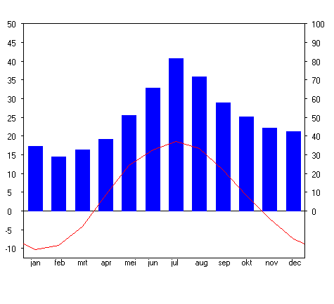

Figure 2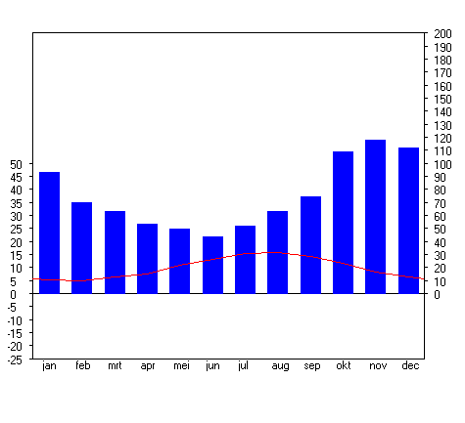

Figure 3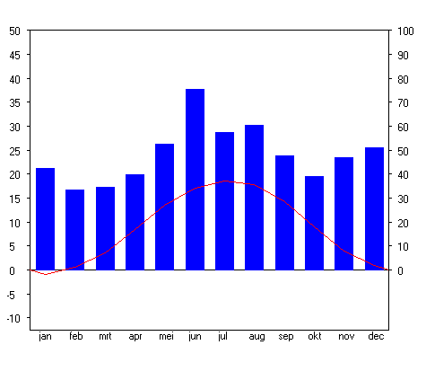
29. Look at this satellite image and the key for the temperature below the map.
When was this image made?

- September 5th
- December 5th
- March 5th
- June 5th

30. You are about to watch a 20 second movie.
Look carefully.
You will see the movie twice.
First read the text below.
What is the most appropriate title for the movie?

A. Pantanal, a famous wetland area in South America
B. Climate change in Brazil
C. Illegal hunting of wild animals in South America
D. Mangrove forest near the rivers Parana and Paraguay

THE END

