**Solution**

1. .

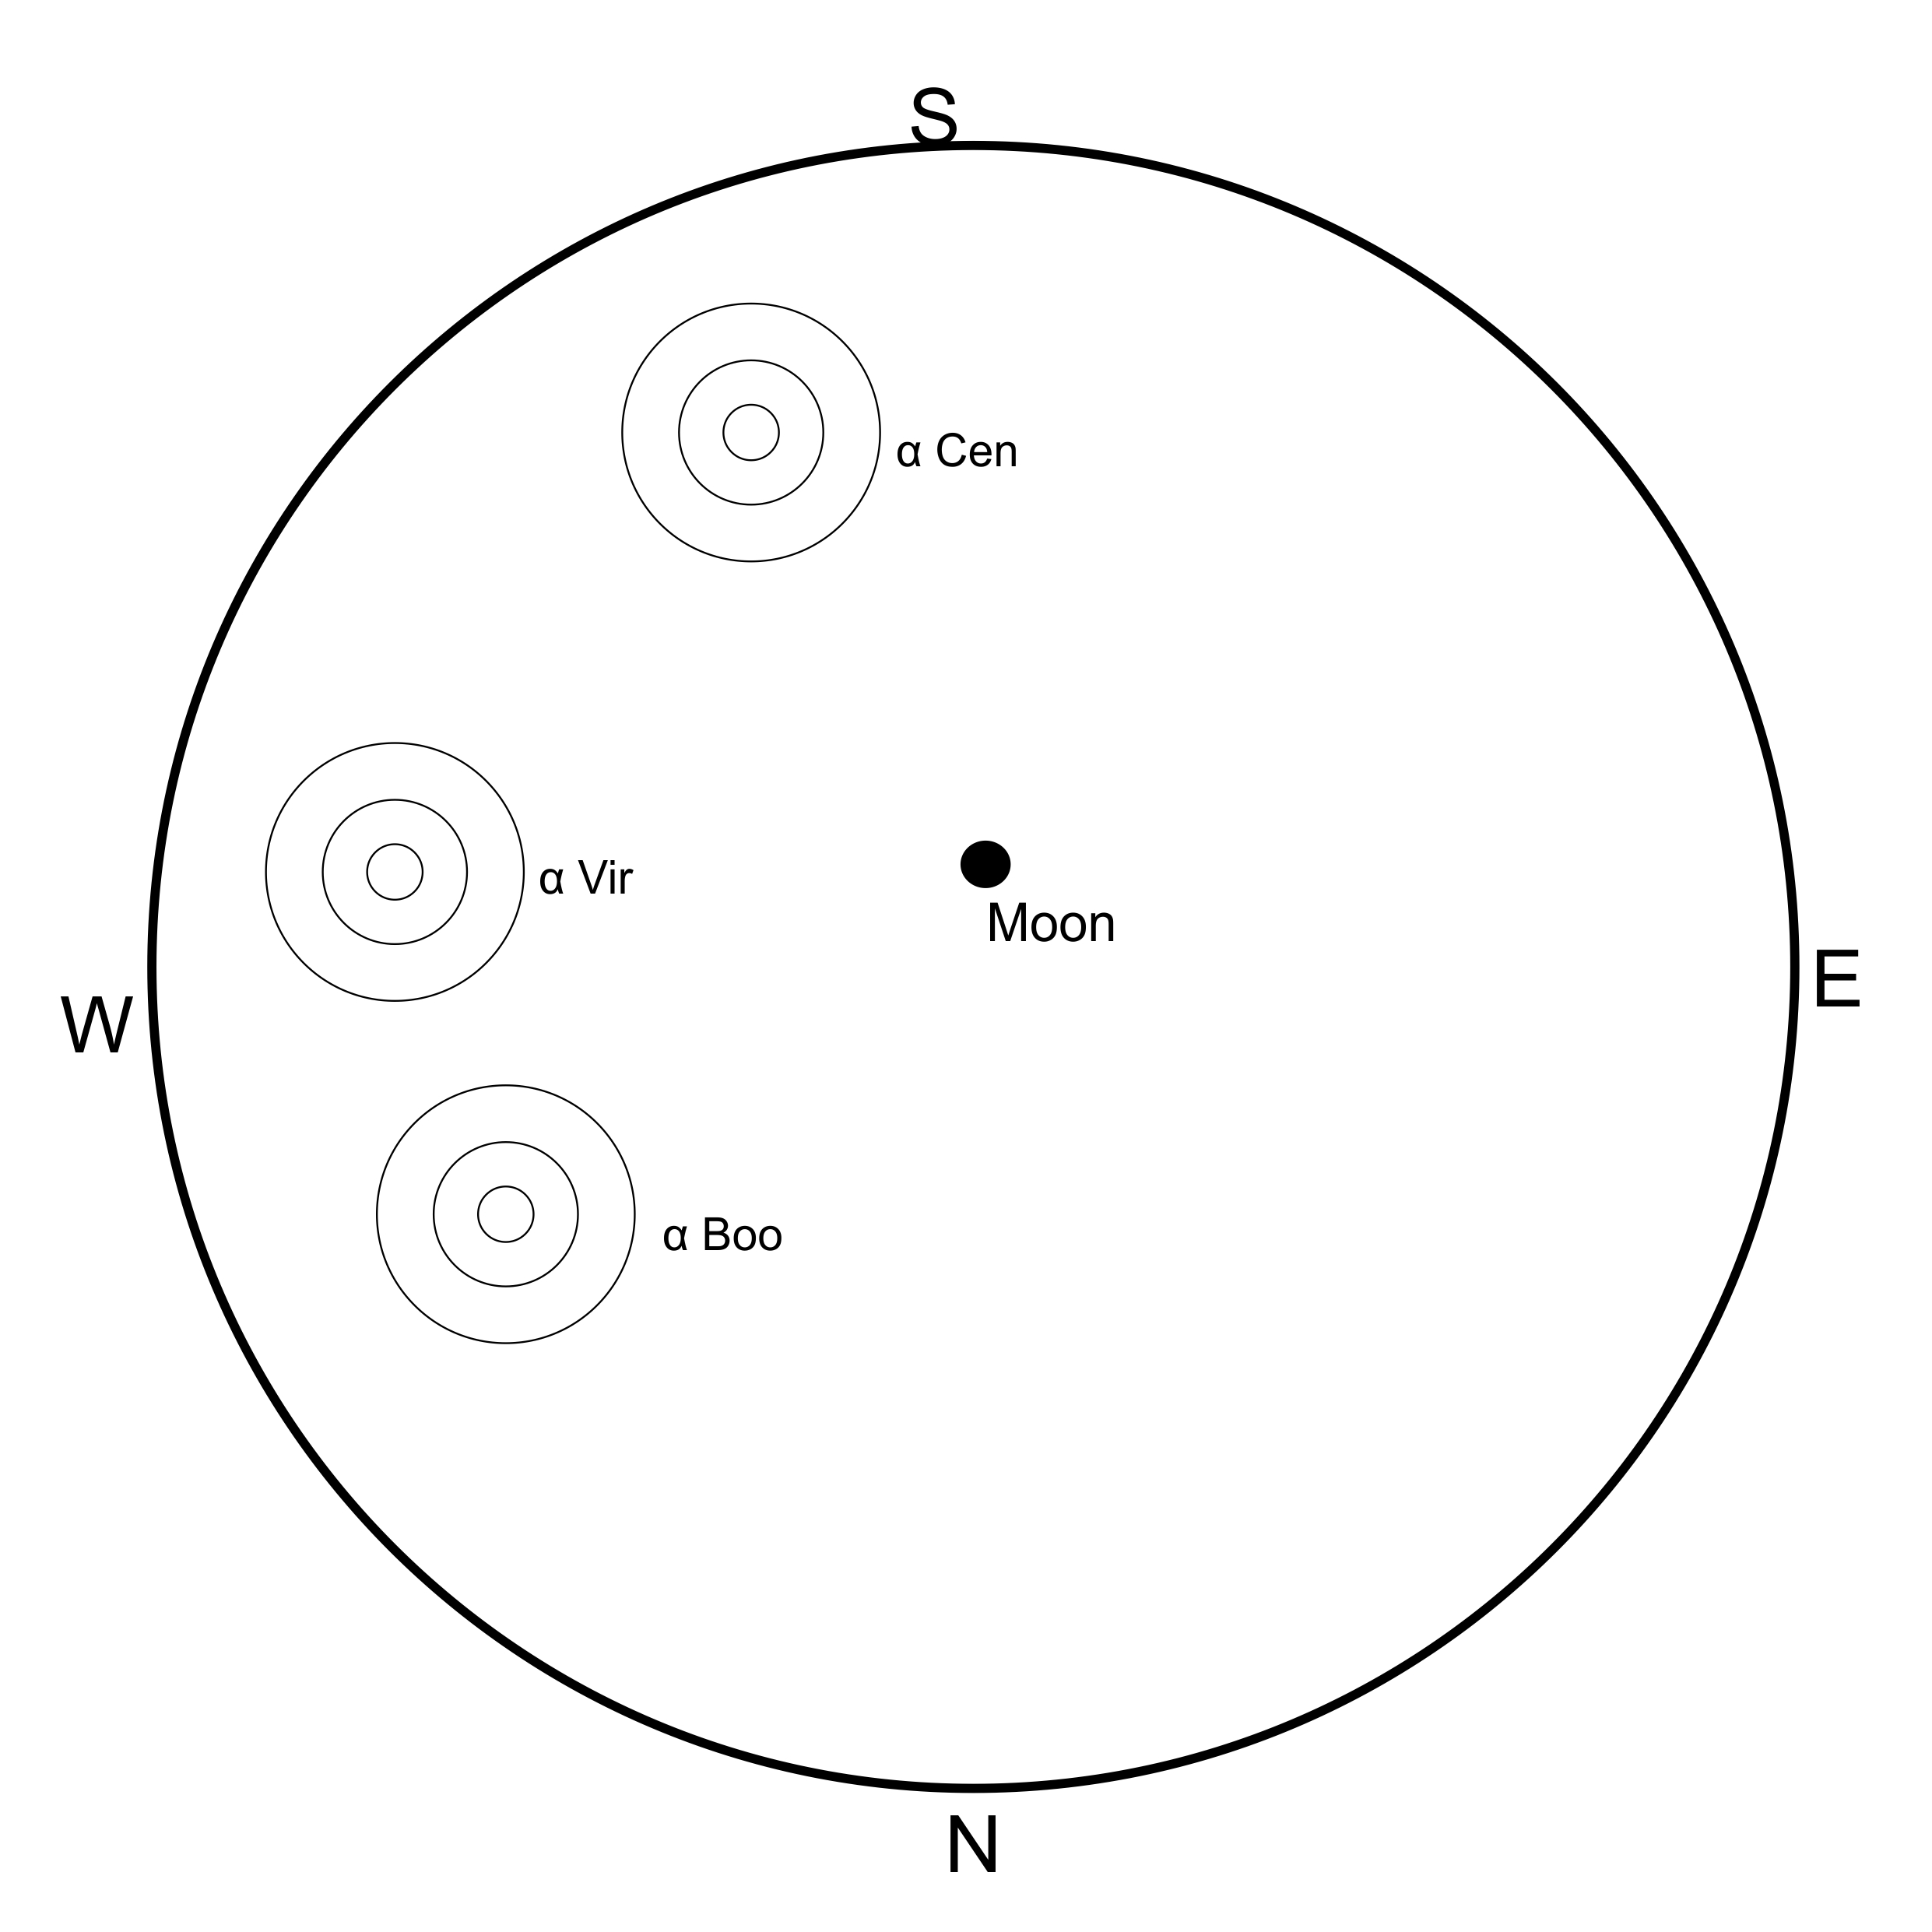

1. .

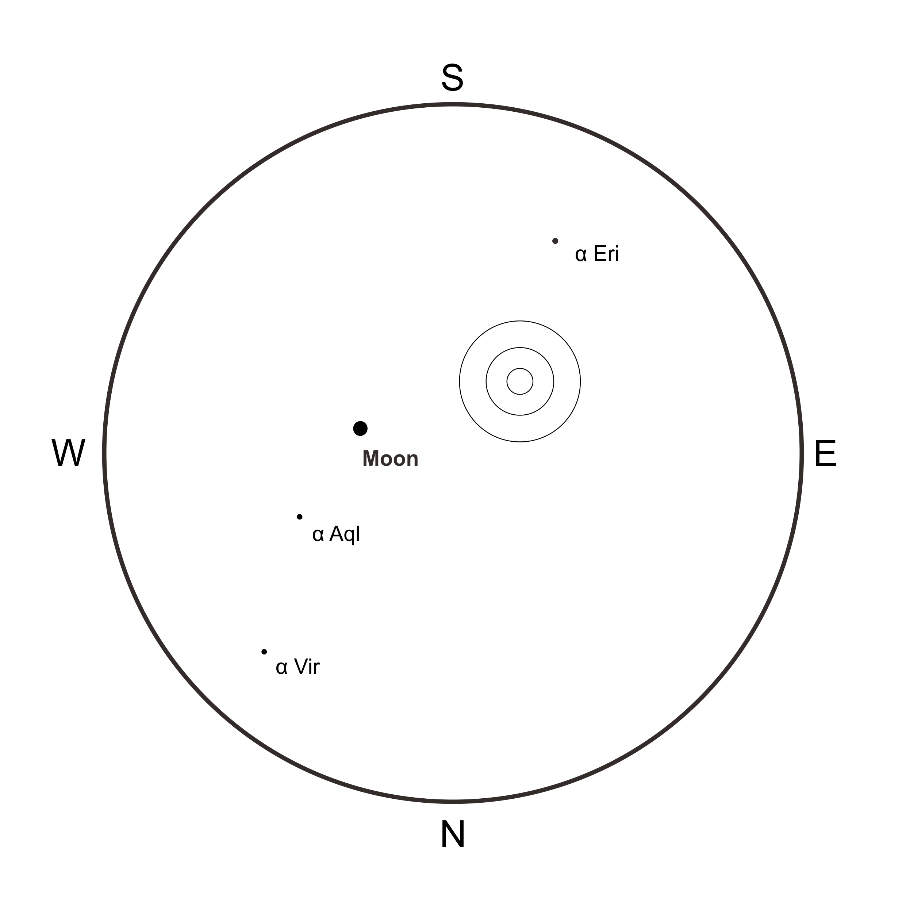

1. Canopus

|  |  |
| --- | --- |
| Rise Time | 16 : 33 : 57 |
| Set Time | 05 : 51: 10 |

Full Mark : + 20 minutes

Half Mark : + 40 minutes

Quarter Mark : + 60 minutes