**PLANETARIUM QUESTIONS**

**(Total Duration: 15 minutes)**

Please pay attention to the North direction marked in the answer sheets.

1. The projected image in the planetarium is a simulated image of the Magelang sky for**July 28, 2015** at **21.00 (UTC+7)**. There are three stars missing in the image. Please mark the position of the three missing bright stars in Answer Sheet 1 by a cross (x) and write their namesbeside the cross marks using their IAU designations. For guidance you can also include a few stars that you see in the planetarium and mark them with circles (o). The list of the bright stars which possibly missing are attached.(Duration: 6 minutes)(60 points)
2. Assume that a bright supernova appears in the sky on **September 24, 2015** and you watch it at **22.00 (UTC+7)**. The planetarium will now show the sky for this date with the supernova. Mark the position of the supernova by a cross (x) in AnswerSheet 2. You can mark other stars by circle (o) for guidance. (Duration: 3 minutes)(50 points)
3. The planetarium will now display the Magelang sky for **January 3, 2016**, at**23.00 (UTC+7)**. The examiner will point to a star with an arrow. Estimate the times at which this star will rise and set from Magelang on this date up to 20 minutes accuracy. (Duration: 6 minutes)(40 points)

**ANSWER SHEET 1**

Answer of question 1:

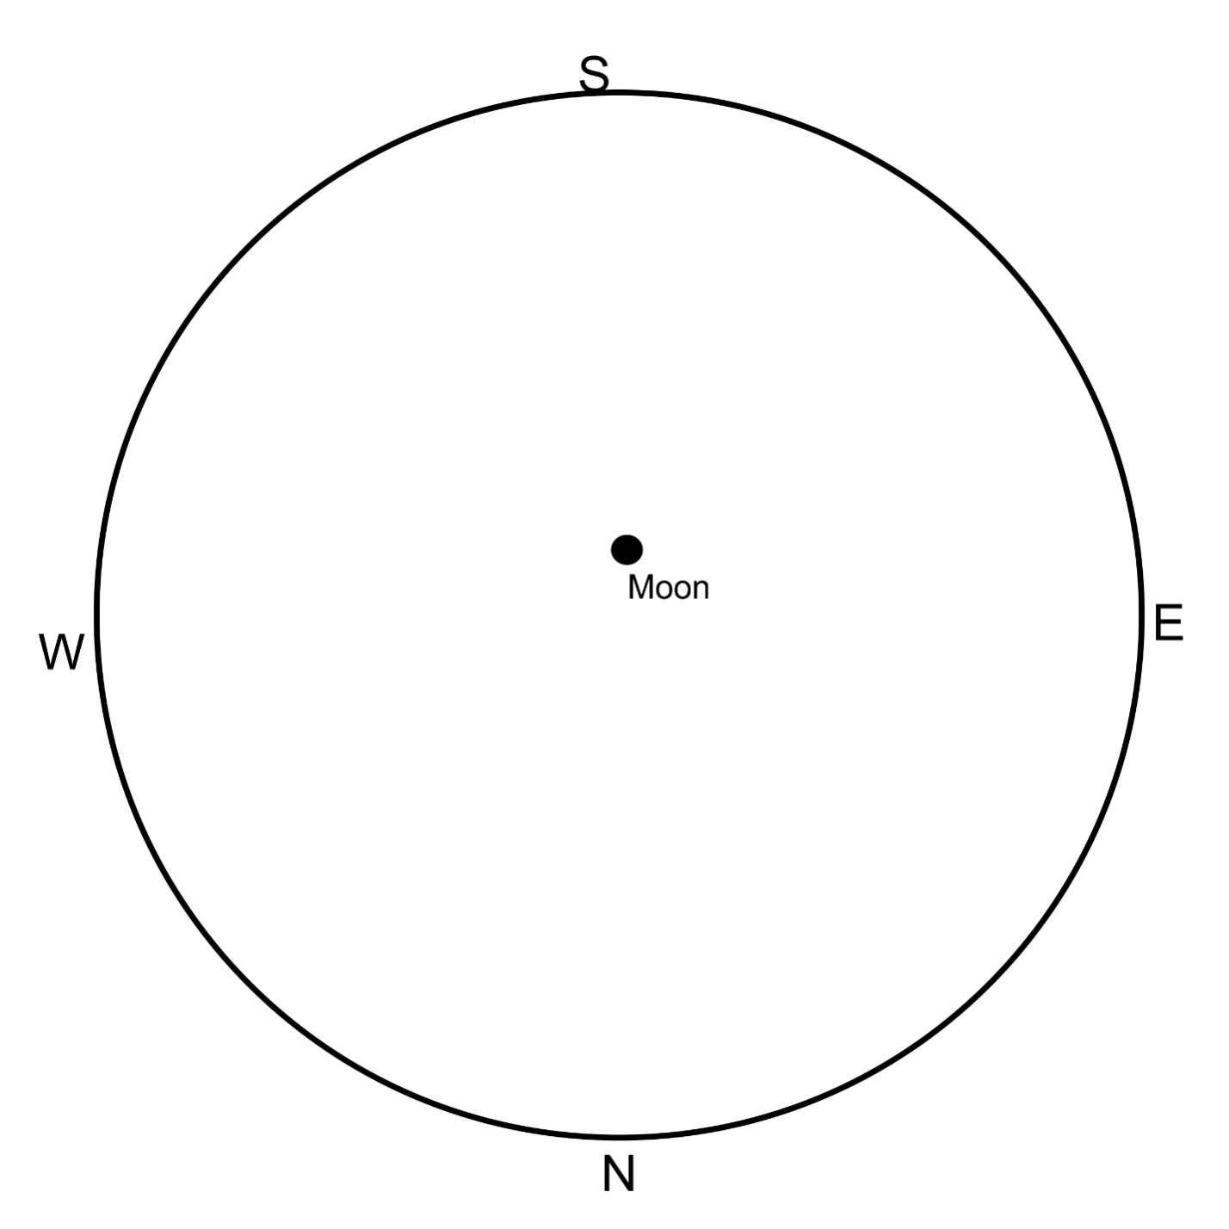

Note: the circumference indicates the horizon.

|  |  |  |
| --- | --- | --- |
| α Pav | α Lyr | α Aql |
| α Vir | α CrB | α Gru |
| α Ser | α Cen | α Cyg |
| α Oph | α Cru | α Boo |
| α PsA | α Sco | β Aqr |
| β Cru | β Oph | β Peg |
| $γ$ Sco | $γ$ Cyg | $δ$ Pav |
| $ε$ Peg | $ε$ Boo |  |

**ANSWER SHEET 2**

Answer of question 2

Answer of Question 3:

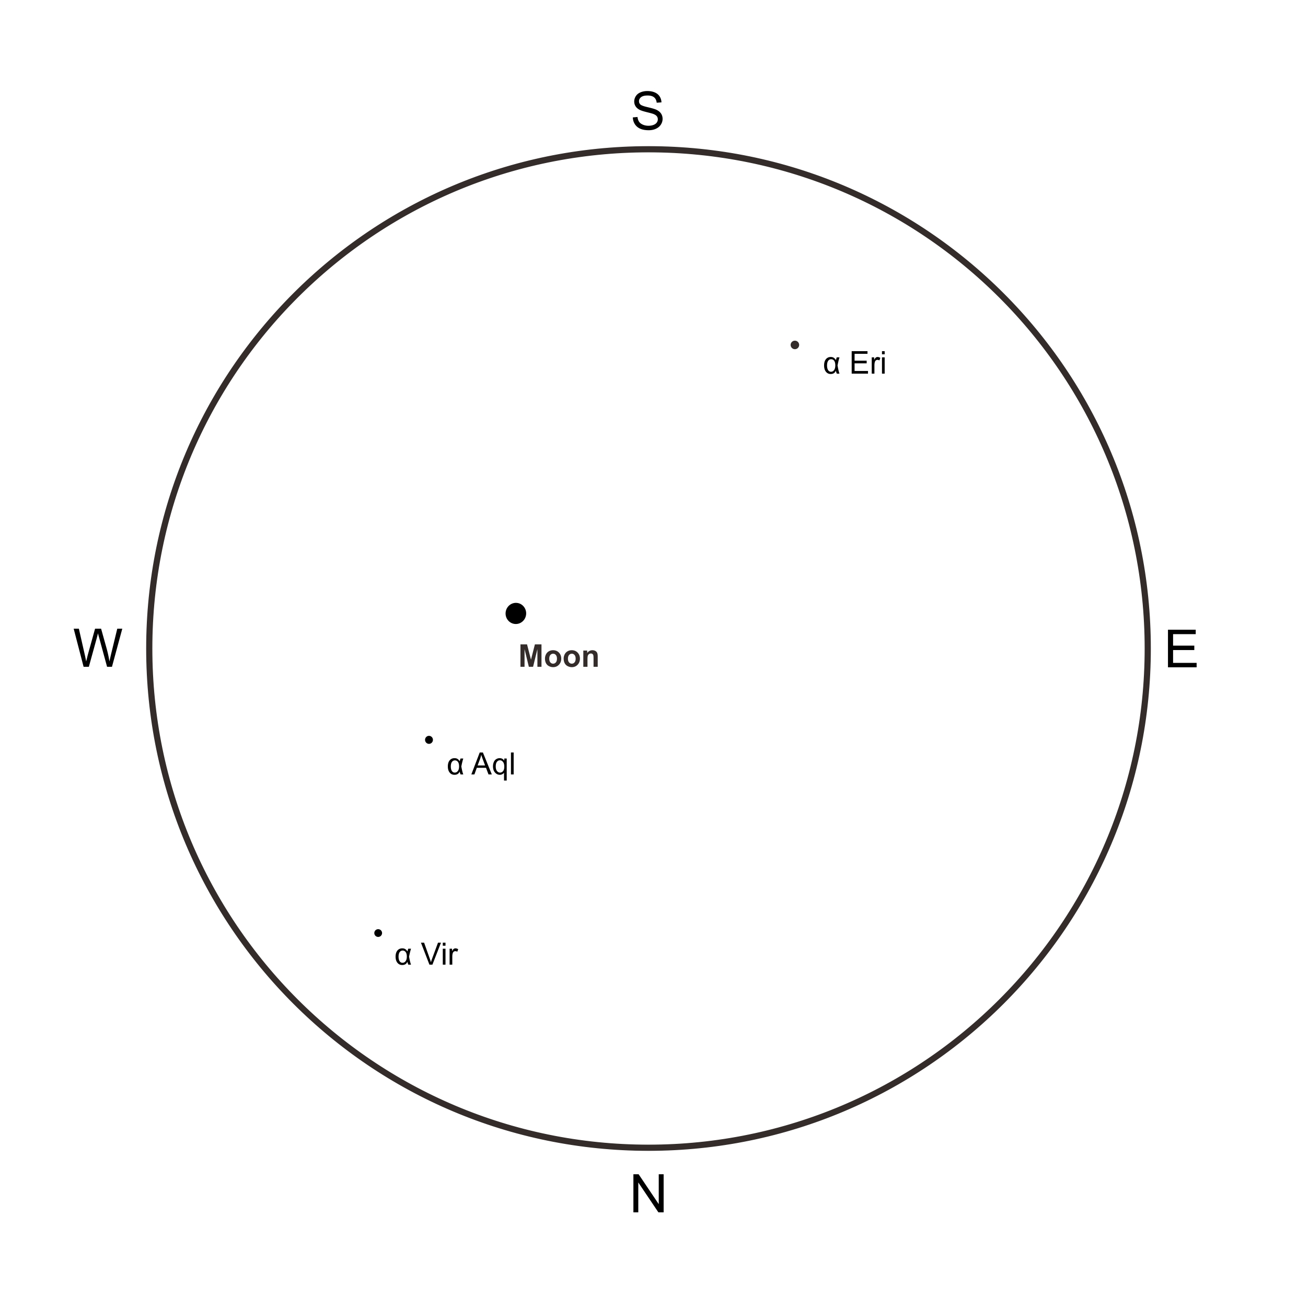

Rise time:

Set time: