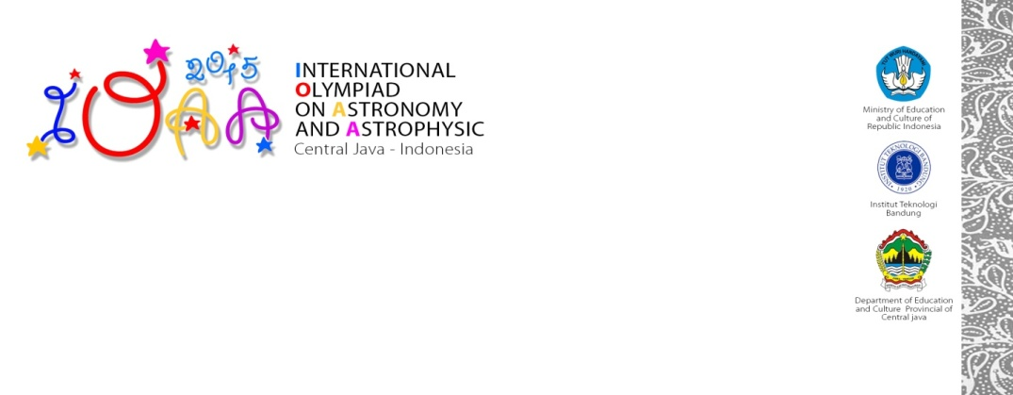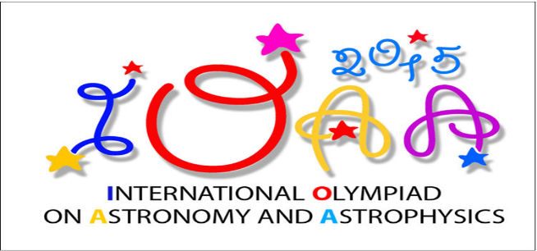

1. During observation test using small telescope, you will receive :

* Problem sheet
* Answer sheet
* Additional sheet
* Flashlight

1. During naked eye test, you will receive :

* Problem sheet
* Answer sheet
* Additional sheet
* Flashlight

1. During observation test using main telescope, you will receive :

* Problem sheet
* Answer sheet
* Additional sheet
* Headlamp
* Clip Board

1. During observation test using planetarium (in case of rainy or cloudy), you will receive :

* Problem sheet
* Answer sheet
* Additional sheet
* Flashlight
* Clip Board

1. Please write your student ID in every answer sheet :
2. The total duration for naked eye + small telescope observation is 60 minutes, main telescope 20 minutes, planetarium 15 minutes