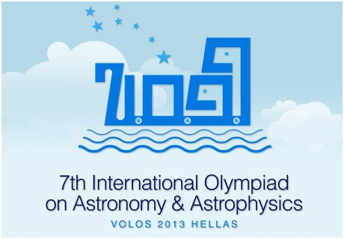

**THE TELESCOPE OF THE 7TH INTERNATIONAL OLYMPIAD ON ASTRONOMY & ASTROPHYSICS**

**SkyWatcher 150/750 Black Diamond EQ3-2**

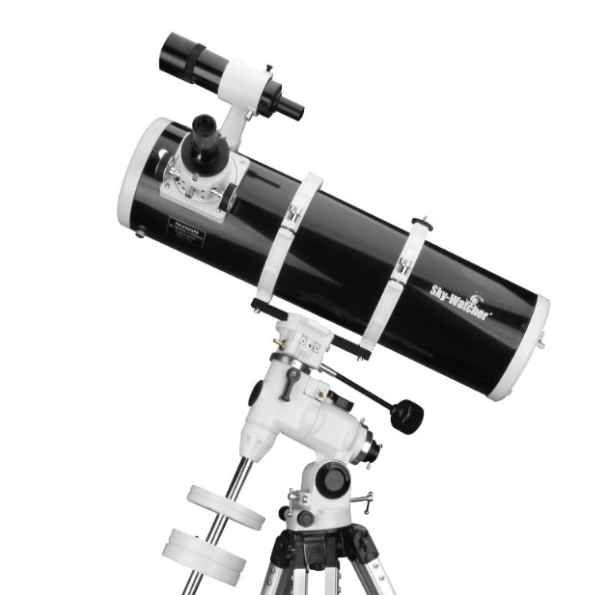

**SPECIFICATIONS**

The telescope of the 7th International Olympiad on Astronomy & Astrophysics

will be a **Newtonian reflector** telescope on equatorial mount

constructed by the **SkyWatcher** company.

**SUMMARY**

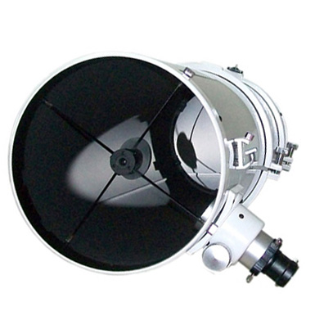

* **Type**: Reflector telescope
* **Optical design**: Newtonian
* **Diameter:** 150 mm (5.91″) (parabolic)
* **Focal length:** F 750 mm
* **Focal Ratio:** f / 5
* **Focuser**: rack and pinion type (with 1.25″ adapter)
* **Mount:** EQ3-2 Equatorial with 2 knobs for manual

movement in RA and Dec and calibrated position

circles.

* 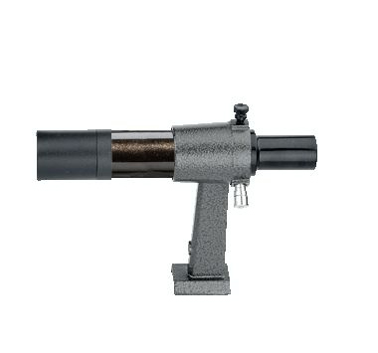**Tripod:** Aluminum legs with adjustable height

(71–123 cm) and leveling bubble

* **Finder:** achromatic 6×30 (inverted image)
* **Eyepieces:** SUPER Plossl 25mm (30×) WA, LE

and SUPER Plossl 10mm (75×), Ø31.8mm

* **Barlow:** 2×, achromatic
* **Maximum Usable Magnification:** 300 ×
* **Minimum Star Magnitude Size:** mV = 13.6
* **Theoretical Resolution:** 0.8 arc sec