Marking scheme

- Correct drawing for Scorpio constellation border : +15 (max)
- Correct drawing for Capricorn constellation border : +15 (max)
- Correct location of 3 bright stars in Scorpio : +10 (max. = 40)
- Correct location of 2 bright stars in Capricorn : +10 (max. = 20)
- Additional correct answer for bright star locations in both constellation, each location: +5
- Correct answer for 3 bright stars in Scorpio : +10 (max. = 40)
- Correct answer for 2 bright stars in Capricorn : +10 (max. = 20)
- Additional correct answer for bright star names in both constellation; each name: +5
MAXIMUM MARK = 150

Answer:

- There are 9 bright stars in Scorpio constellation in the Table 1

Number | Common Names | Bayer designation
2 | Acrab Graffias | β Sco.
8 | Girtab | κ Sco
11 | Dschubba | δ Sco.
16 | Antares (given) | α Sco.
20 | Shaula | λ Sco
21 | Vrischika | π Sco
26 | Wei | ε Sco
29 | Lesath | υ Sco
34 | Sargas | θ Sco

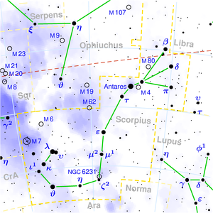
- There are 4 bright stars in Capricorn constellation in the Table 1

Number | Common Names | Bayer Designation
7 | Dabih | β Cap.
13 | Algiedi | α Cap.
23 | Deneb Algedi | δ Cap.
28 | Nashira | γ Cap.

