Marking scheme:

Student who has the highest number of stars identified (N_{m}) = 60%
Other students who get N stars = N*0.60/N_{m}
Estimation of the limiting magnitude = 0 − 20%
(Δ<1 mag : full mark, 1<Δ<2 mag half mark, Δ>3 mag : 0)
Good image quality (unsaturated, not under expose) 20%

TOTAL MARK = 100
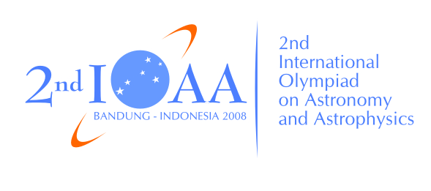
Answer Page
Sky chart Image
Country and Student codes: ……………….………………………….

Selected region : M7 (α=17^{h}53.^{m}3, δ= -34º46.’2)

Central equatorial coordinates : α=17^{h}54^{m}22.3^{s}, δ= -34º47’15”
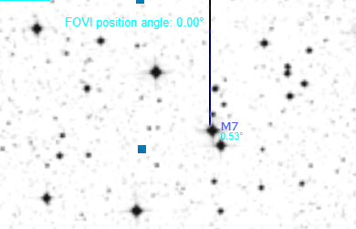
Figure 1

Answer Page
CCD Image 1
Country and Student codes: ……………….………………………….

Figure 2
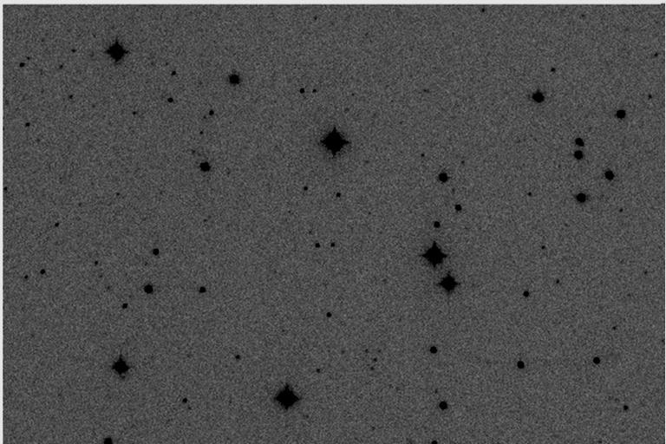
1
2
3
4
5
6

Exposure time: 5 sec
Answer Page
Identification
Country and Student codes: ……………….………………………….

Number | Names or Catalogue number | R.A. | Declination | Magnitude
1 | SAO 209436 | 17h 54m 14.380s | -34°43'39.535" | 6.88
2 | GSC 7386:494 | 17h 54m 09s | -34°44'31" | 11.6
3 | GSC 7386:601 | 17h 54m 06s | -34°44'44" | 12.2
4 | GSC 7386:561 | 17h 54m 04s | -34°44'06" | 8.5
5 | GSC 7386:15 | 17h 53m 55s | -34°48'20" | 11.9
6 | GSC 7386:40 | 17h 54m 13s | -34°48'18" | 11.8

Limiting magnitude of the photograph is ………………………………………

Answer Page
Sky chart Image
Country and Student codes: ……………….………………………….

Selected region : M8 (α=18^{h}04.^{m}2, δ= -24º22.’1)

Central equatorial coordinates : α=18^{h}04^{m}51^{s}.2; δ=-24º23’04”

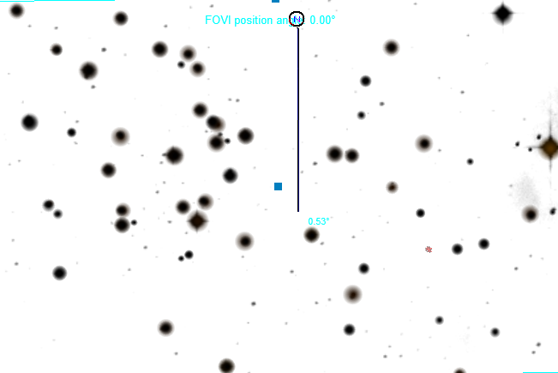
Figure 1

Answer Page
CCD Image 1
Country and Student codes: ……………….………………………….

Figure 2
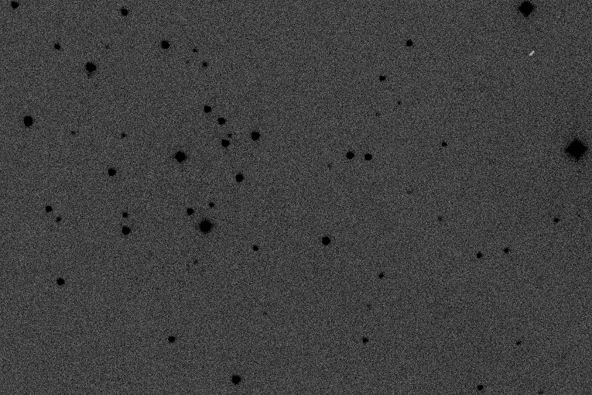
1
2
3
4
5

Exposure time: 10 sec
Answer Page
Identification
Country and Student codes: ……………….………………………….

Number | Names or Catalogue number | R.A. | Declination | Magnitude
1 | GSC 6842:1751 | 18h 04m 10s | -24°20'53" | 12.5
2 | GSC 6846:166 | 18h 04m 05s | -24°23'01" | 12.1
3 | GSC 6846:211 | 18h 03m 58s | -24°25'35" | 12.0
4 | GSC 6846:718 | 18h 04m 27s | -24°23'52" | 12.4
5 | GSC 6842:1578 | 18h 04m 23s | -24°21'25" | 13.4

Limiting magnitude of the photograph is ………………………………………
Answer Page
Sky chart Image
Country and Student codes: ……………….………………………….

Selected region : M20 (α=18^{h}02.^{m}4, δ= -22º58.’7)

Central equatorial coordinates : α=18^{h}02^{m}56^{s}.7, δ=-23º01’56”

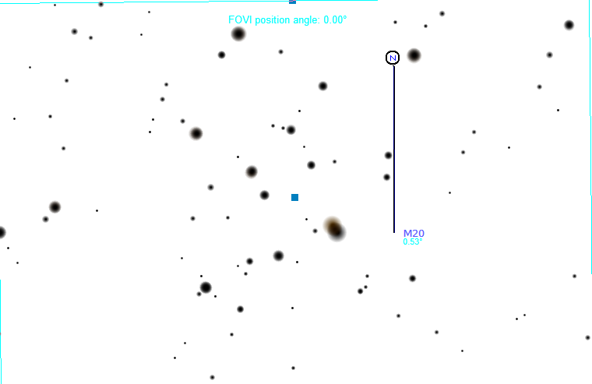
Figure 1

Answer Page
CCD Image 1
Country and Student codes: ……………….………………………….

Figure 2
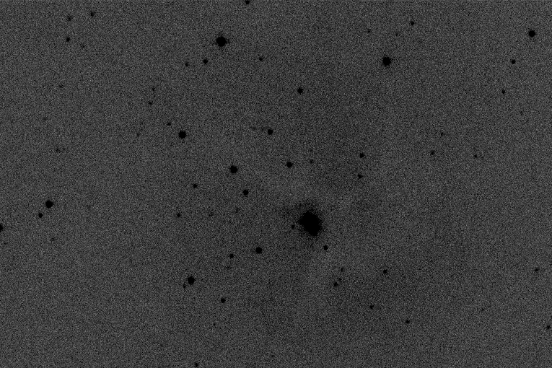
1
2

Exposure time: 10 sec
Answer Page
Identification
Country and Student codes: ……………….………………………….

Number | Names or Catalogue number | R.A. | Declination | Magnitude
1 | GSC 6842:631 | 18h 02m 18s | -23°00'25" | 12.4
2 | GSC 6842:240 | 18h 02m 19s | -23°00'52" | 12.8

Limiting magnitude of the photograph is ………………………………………
Answer Page
Sky chart Image
Country and Student codes: ……………….………………………….

Selected region : M21 (α=18^{h}04.^{m}2, δ= -22º29.’5)

Central equatorial coordinates : α=18^{h}04^{m}46^{s}.3, δ=-22º29’27”

Figure 1
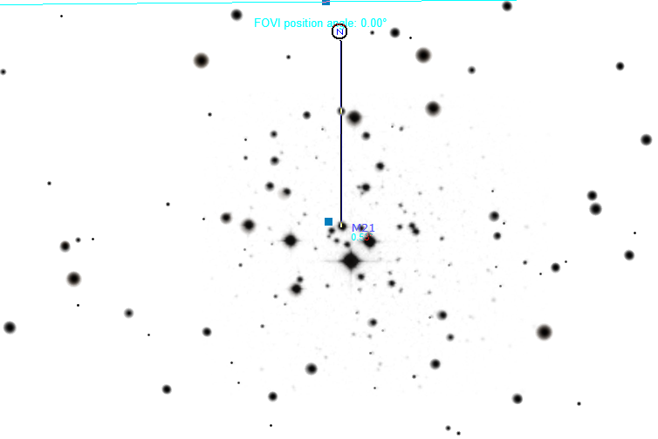
Answer Page
CCD Image 1
Country and Student codes: ……………….………………………….

Figure 2
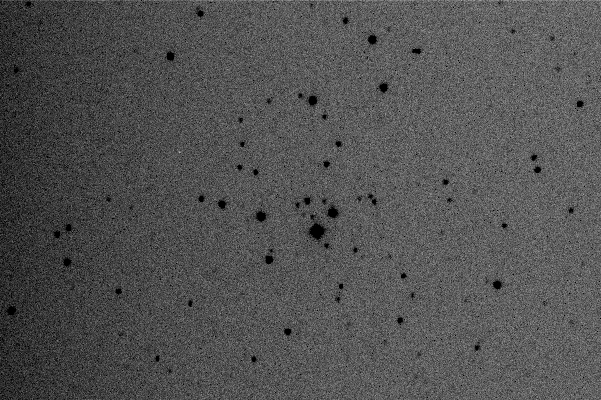
1
2

Exposure time: 10 sec
Answer Page
Identification
Country and Student codes: ……………….………………………….

Number | Names or Catalogue number | R.A. | Declination | Magnitude
1 | GSC 6842:985 | 18h 04m 09s | -22°30'28" | 12.9
2 | GSC 6263:306 | 18h 04m 01s | -22°29'36" | 13.1

Limiting magnitude of the photograph is ………………………………………
Answer Page
Sky chart Image
Country and Student codes: ……………….………………………….

Selected region : M23 (α=17^{h}57.^{m}0, δ= -18º59.’4)

Central equatorial coordinates : α=17^{h}57^{m}32^{s}.1, δ=-19º01’08”

Figure 1
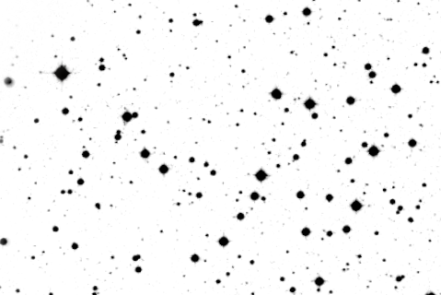
Answer Page
CCD Image 1
Country and Student codes: ……………….………………………….

Figure 2
1
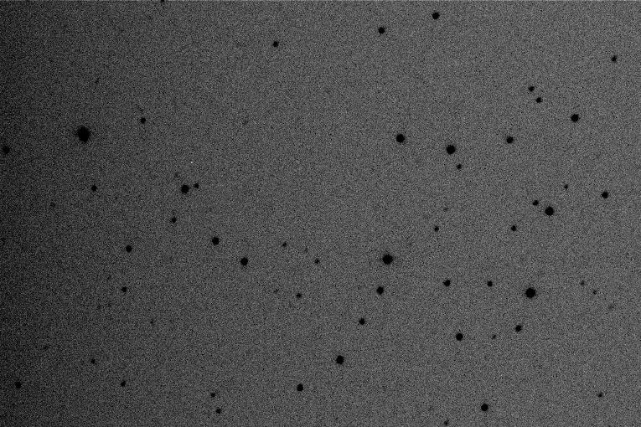
2
Exposure time: 10 sec
Answer Page
Identification
Country and Student codes: ……………….………………………….

Number | Names or Catalogue number | R.A. | Declination | Magnitude
1 | GSC 6258:809 | 17h 56m 58s | -18°58'21" | 13.2
2 | GSC 6258:825 | 17h 56m 59s | -18°58'43" | 12.5

Limiting magnitude of the photograph is ………………………………………

