АСТРОНОМИЧЕСКОЕ  ОБЩЕСТВО |  | 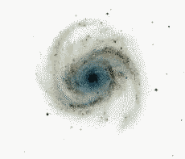 | EURO–ASIAN  ASTRONOMICAL SOCIETY
 | VIII Международная астрономическая олимпиада  VIII International Astronomy Olympiad  VIII:e Internationella Astronomiolympiaden

Швеция, Cтокгольм 2 – 8. 10. 2003 Stockholm, Sweden

Тезисы решений задач практического тура
Practical round. Sketches for solutions
язык | English
language | English

Groups A,B

8. Estimating the mass of Saturn

8.1. If Saturn’s ring was a rigidly rotating body, its outer edge would be faster than its inner edge, and the spectrum would look like Fig. 3.
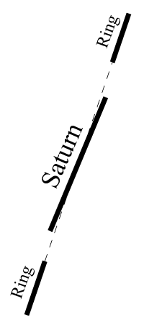
Figure 3 The rotation curve for Saturn with a rigid ring. The rotation curve of the ring is a straight line, with the outer edge rotating faster than the inner, and with the whole ring approximately at the Kepler velocity.
8.2. We start by determining the scale of the spectrum. The distance between the two Na I lines in the spectrum of Fig. 2 is 84 mm. Since we know the two D lines of Na I to differ by 0.59 nm, we have the spectral scale 0.59/84 nm/mm = 0.007024 nm/mm.
Light from the solar spectrum is received by the reflecting surface of Saturn at a Doppler shift depending on the velocity of the surface with respect to the Sun. With respect to an observer, the light reflected on the surface is then again Doppler shifted with the velocity between the observer and the surface. From the small shadow of Saturn on its ring in Fig. 1, we note that the angle between the Earth and the Sun, as seen from Saturn, is small. Thus the Doppler shift differences between different parts of the surface (and the rings) are approximately just doubled, i.e. Δλ/λ₀ = 2v/c.
However, we observe Saturn at an inclination, meaning that we observe only the component of the velocity pointing in our direction. Since the ring system is circular in shape and planar, we can measure the projection factor by measuring the dimensions of the projected ring. The major axis of the ring measured in Fig. 1 is 116 mm, while the minor axis is 51 mm. By Pythagoras’s theorem (see Fig. 4), this gives the projection factor
(116²-51²)^{1/2} / 116 = 0.90.
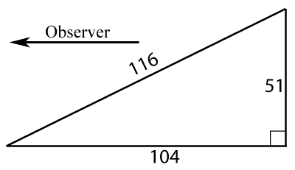
Figure 4 If the velocity is 116, then the projected velocity component in the direction of the observer is 104, that is, the projection factor is 104/116 = 0.90.
For the spectrum of Fig. 2, this translates to the velocity scale
0.5×0.007024×c/(589.3×0.90) mm⁻¹ = 1.98 km/s mm⁻¹.
We can now calculate the difference in velocity between the different edges of the planetary disc. The difference is about 10 mm, meaning 20 km/s. During the period 10.66 h = 38000 s, the surface thus travels 10×38000 km = 380000 km, which is the equatorial circumference of Saturn. Dividing by π we get the diameter 121000 km.

8.3. Since the equatorial diameter of the planet is 121000 km but 18 mm in the spectrum of Fig. 2, the image scale is 121000/18 km/mm = 6700 km/mm. Looking at the inner part of the ring, the displacement of an absorption line between the two sides is 20 mm, corresponding to the velocity difference 20×1.98 km/s = 39.7 km/s. The diameter of the inner ring is 26 mm in Fig. 2, meaning 26×6700 km = 175000 km. Using Kepler’s third law,
${\left(\frac{P}{\text{yr}}\right)}^{2}=\frac{{\left(a/\text{AU}\right)}^{3}}{M/M_{\text{Sun}}}$,
where yr = 3.16×10⁷ s, AU = 1.496×10⁸ km and M_{Sun} = 1.99×10³⁰ kg. The circumference of the ring of diameter 175000 km is 549000 km, giving the period 549000 / (39.7×0.5) = 27700 s. Thus Saturn’s mass is calculated as
$M=\frac{{\left(a/\text{AU}\right)}^{3}}{{\left(P/\text{yr}\right)}^{2}}M_{\text{Sun}}=\frac{{\left(8\text{.}\text{74}×{\text{10}}^{4}/1\text{.}\text{496}×{\text{10}}^{8}\right)}^{3}}{{\left(2\text{.}\text{77}×{\text{10}}^{4}/3\text{.}\text{16}×{\text{10}}^{7}\right)}^{2}}1\text{.}\text{99}×{\text{10}}^{\text{30}}\text{kg}=5\text{.}2×{\text{10}}^{\text{26}}\text{kg}$.
What is the expected accuracy of this number? Assuming our measurements on paper are accurate to ±0.5 mm, one can derive the formal error 5×10²⁵ kg. The mass of Saturn, as measured accurately by Voyager, is 5.685×10²⁶ kg, consistent with our value.

Швеция, Cтокгольм 2003 Stockholm, Sweden

