АСТРОНОМИЧЕСКОЕ  ОБЩЕСТВО |  | 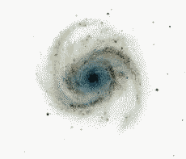 | EURO–ASIAN  ASTRONOMICAL SOCIETY
 | VIII Международная астрономическая олимпиада  VIII International Astronomy Olympiad  VIII:e Internationella Astronomiolympiaden

Швеция, Cтокгольм 2 – 8. 10. 2003 Stockholm, Sweden

Задачи практического тура Practical round. Problems to solve
язык | English
language | English

Group B

8. Estimating the mass of Saturn

Introduction
Ever since Galileo Galilei observed the ring of Saturn through a telescope for the first time, it has been regarded as one of the prime astronomical sights. The ring itself is not a rigid body, but consists of innumerable moonlets in Keplerian orbits around the planet, as shown spectroscopically almost simultaneously by Aristarkh A. Belopolsky and by James E. Keeler. The results of the latter were published in the very first issue of the Astrophysical Journal in 1895. In this problem, you are asked to repeat their argument using recent observations, and estimate the mass of Saturn.

Observational details
Saturn was observed by the Nordic Optical Telescope (NOT, a 2.5 m telescope on the Canary Island La Palma) 2002-02-25 at 23:25 Universal Time. A spectroscopic slit was placed over the planet as shown by Fig. 1. The retrieved spectrum (Fig. 2) shows the solar spectrum reflected on the planet. The straight vertical absorption lines are telluric, i.e. absorption lines arising when the light travels through the Earth's atmosphere, while the lines seen at inclination are the solar absorption lines reflected against the planet. The two strongest absorption lines seen in the spectrum are from the Na I (neutral sodium) D₂ and D₁ transitions, at rest wavelengths 589.00 nm and 589.59 nm respectively.

Problems
Note: You must carefully account for every step in your calculation. Answers without motivation will not be accepted.
8.1. The spectrum of Fig. 2 implies that the ring of Saturn cannot be a rigidly rotating body. Draw a figure that qualitatively shows what the spectrum would look like, if the ring was indeed rotating rigidly. (~20%)
8.2. The sidereal rotation period of Saturn is known to be 10.66 hours. Estimate the equatorial diameter of Saturn from the spectrum of Fig. 2. (~30%)
8.3. Estimate the mass of Saturn implied by the spectrum of Fig. 2. If you cannot remember the gravitational constant, you may use that 1 AU = 1.496×10⁸ km and the mass of the Sun is M_{Sun} = 1.99×10³⁰ kg. (~50%)
You may use the fact that the ring of Saturn is planar and parallel to the planet’s equator to calculate the inclination of the system relative to the line of sight.
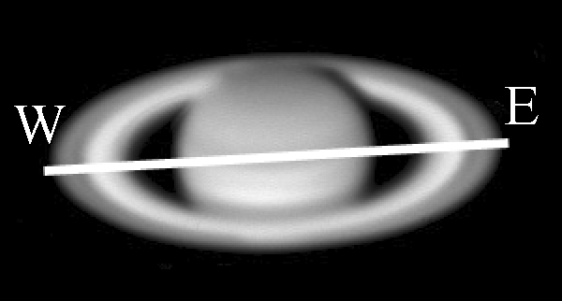
Figure 1
Position of the spectroscopic slit on Saturn. West and East are marked by W and E respectively.

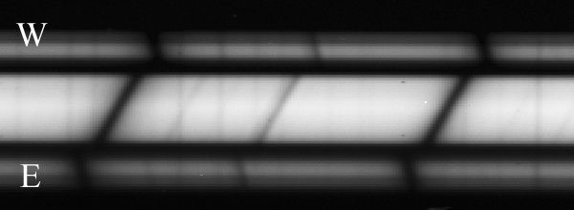
Figure 2
The solar spectrum reflected on Saturn. West is up, and wavelengths increasing to the right.

Швеция, Cтокгольм 2003 Stockholm, Sweden

