АСТРОНОМИЧЕСКОЕ  ОБЩЕСТВО |  | 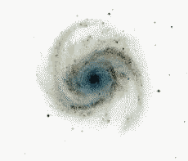 | EURO–ASIAN  ASTRONOMICAL SOCIETY
 | VIII Международная астрономическая олимпиада  VIII International Astronomy Olympiad  VIII:e Internationella Astronomiolympiaden

Швеция, Cтокгольм 2 – 8. 10. 2003 Stockholm, Sweden

Задачи практического тура Practical round. Problems to solve
язык | English
language | English

Groups A,B

7. Measuring the speed of light
Note: You must carefully account for every step in your calculations. Answers without motivation will not be accepted.
Imagine that the solar system in a distant future becomes inhabited by our descendants. On the asteroid Saltis, a small robotic mining establishment is supervised by Celesta Spacedigger, who also happens to be a dedicated amateur astronomer. Being bored by her job, Celesta spends the long nights of Saltis studying the stars and the planets, in particular the glorious planet Saturn. An old but reliable astronomical almanac helps her keeping track of celestial events like eclipses of the moon Titan by its planet Saturn. To her dismay, however, Celesta starts to note large deviations between her observed times of the eclipses of Titan and the tabulated ones. After years of careful observations (she has a long term assignment on Saltis) she begins to see a pattern; the deviations are largest when Saturn is close to opposition or conjunction (with the Sun, as seen from Saltis). She realises that this must be due to the finite speed of light, and a check in her almanac confirms that the tabulated timings are heliocentric, that is, as seen from the Sun, and not as seen from Saltis. Quite satisfied with her discovery, Celesta use her observations to calculate the speed of light.
In this problem you are asked to repeat Celesta’s calculations by using her observations. The units of length and time that Celesta uses are a bit different from what you are used to. The unit of time is called pinit, and is defined such that there are 1000 pinit in one synodic rotation of Saltis. The length unit is called seter and is defined to be one billionth (10⁻⁹) of the mean distance between the Sun and Saltis.
Table 1 Eclipses of Titan by Saturn
Tabulatedª  (pinit) | Celesta^{b}  (pinit) | Comment^{c}
456.47 | 450.32 | Opposition
18.50 | 12.28 | Opposition
821.41 | 815.29 | Opposition
444.70 | 450.85 | Conjunction
615.43 | 621.52 | Conjunction
791.94 | 798.02 | Conjunction
ª The tabulated values refer to when an observer located at the Sun would observe the beginning of the eclipse.
^{b} Celesta observed timing of the beginning of the eclipses from Saltis. Her estimated accuracy in the timing is 0.03 pinit.
^{c} The position of Saturn during an eclipse of Titan was never exactly in opposition or conjunction, but close to.
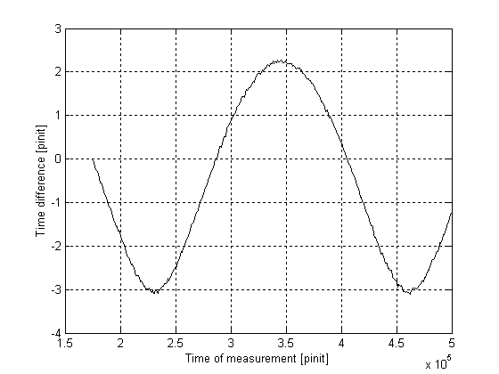
Figure 1 Difference between Celesta’s watch and the time signal received from Earth.
7.1. Celesta observed eclipses of Titan when Saturn was close to opposition or conjunction during six occasions (Table 1). Analyse her data carefully and estimate the speed of light, in units of seter per pinit, and give the expected error of your estimate. (50%)
Celesta also enjoys listening to radio signals from Earth during her lonely days. With her re-discovery of the finite speed of light, Celesta gained enough confidence to try and measure the orbital radius of Earth (in seter). She synchronises her very accurate watch with a radio time signal from Earth, and then regularly follows how the time of her watch differs from the periodic time signal. Her measurements are presented in Fig. 1.
7.2. Use Celesta’s data in Fig. 1 to estimate the radius of Earth’s orbit in seter. (20%)
7.3. With 1 AU = 149.6·10⁶ km and c = 2.998·10⁸ m/s, how many meter is a seter? How many seconds is a pinit? (10%)
7.4. Estimate the orbital period (in years) of Saltis from Fig. 1 and the answer to problem 3. (20%)

Attention: for group A there is the only problem Nr.7 on the Practical round for 3 hours;
for group B there are the two problems: Nr.7 and Nr.8 for 4 hours.

Швеция, Cтокгольм 2003 Stockholm, Sweden

